- Create a customized Docker image using a Dockerfile.
- Push the image to Docker Hub.
- Push the same image to Amazon ECR.
- Provision one EC2 instance using Terraform and install Jenkins.
- Create one Jenkins job to build and push the Docker image to Docker Hub.
  - Source: https://github.com/betawins/Python-app.git
Source Codes: https://github.com/betawins/docker-tasks.git

- From the frontend source code, write a Dockerfile, build a Docker image, run it, and push that image to your Docker registry.
- From the Java-based source code, write a Dockerfile, build, run, and push the image to the Docker registry.
- From the Node.js-based source code, write a Dockerfile, build with tagv1, run, and push it to the Docker registry.
- Write a docker-compose file to set up WordPress with a MySQL database.

Challenge 1 — Create a Customized Docker Image Using a Dockerfile
We'll do this using the Python application from:
Python-app GitHub repository
Our target is:
GitHub Python App
↓
Clone
↓
Inspect files
↓
Create Dockerfile
↓
docker build
↓
Docker Image
↓
docker run
↓
Test application

Step 1 — Clone the repository
On your Docker/EC2 server, run:
git clone https://github.com/betawins/Python-app.git
Then enter the directory:
cd Python-app
Check the files:
ls -la
Also run:
cat requirements.txt
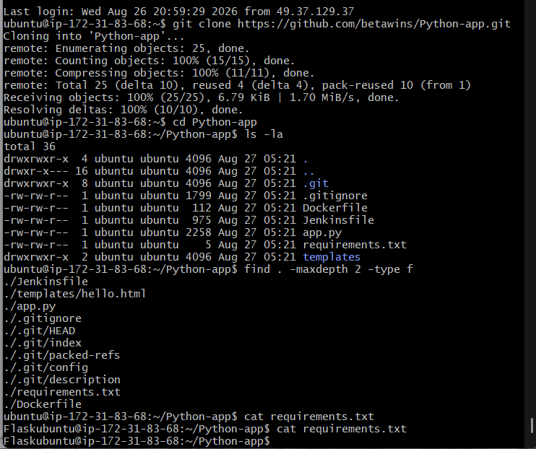

Step 2 — Check app.py
Before changing the existing Dockerfile, let's check the application's port and startup configuration.
Run:
cat app.py
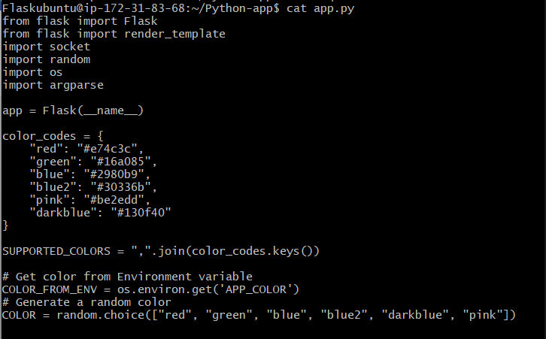
Step 3: check the existing Dockerfile:
cat Dockerfile
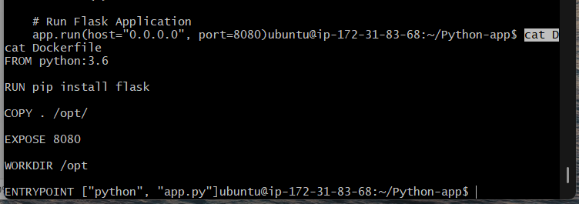

Why we need these two files
app.py tells us:
- How Flask is started
- Which port it listens on
- Whether it listens on 127.0.0.1 or 0.0.0.0
The existing Dockerfile may already contain part of the solution, and we can decide whether to modify it or create the customized version from scratch.

Step 4 — Create Dockerfile
FROM python:3.6

WORKDIR /opt

COPY requirements.txt .

RUN pip install --no-cache-dir -r requirements.txt

COPY . .

EXPOSE 8080

ENTRYPOINT ["python", "app.py"]
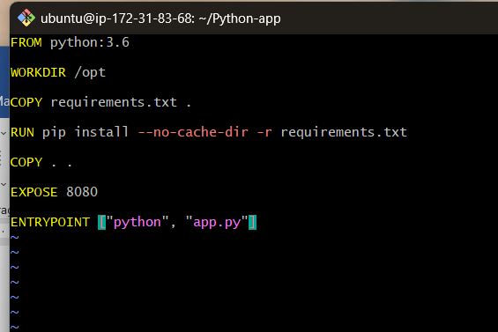

Understand the Dockerfile

FROM
FROM python:3.6
Specifies the base image. It provides the Python runtime required to execute the application.

WORKDIR
WORKDIR /opt
Sets /opt as the working directory inside the container.

COPY
COPY requirements.txt .
Copies requirements.txt from the host into the container's /opt directory.

RUN
RUN pip install --no-cache-dir -r requirements.txt
Installs Flask and other dependencies listed in requirements.txt.

COPY
COPY . .
Copies the application source code into the container.
This includes:
app.py
templates/
requirements.txt
and other files in the build context.

EXPOSE
EXPOSE 8080
Documents that the application listens on port 8080 inside the container.

ENTRYPOINT
ENTRYPOINT ["python", "app.py"]
Specifies the command that automatically starts when the container runs.

Step 5 — Build Docker Image
docker build -t python-app:v1 .

Explanation
docker build
Tells Docker to build an image.
-t
Assigns a name and tag to the image.
python-app
Image name.
v1
Image tag/version.
.
Uses the current directory as the Docker build context.
So the complete command means:
Build a Docker image using the Dockerfile in the current directory and name it python-app:v1.

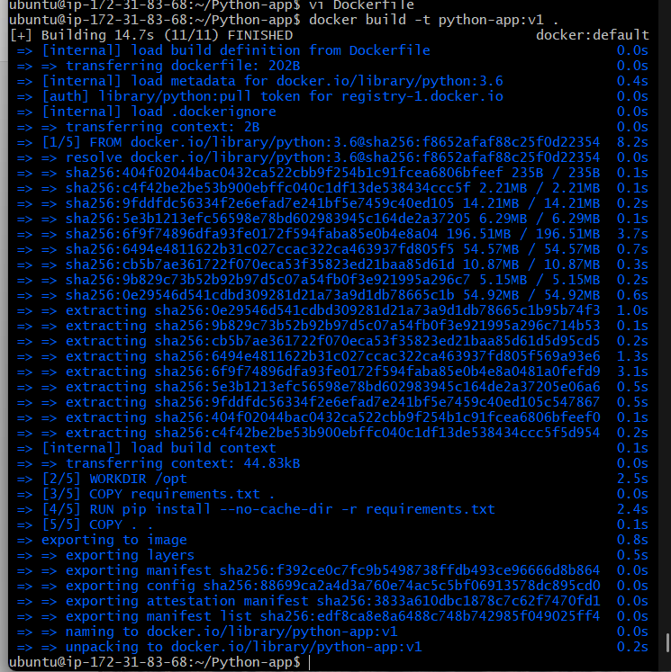

Step 6 — Verify Docker Image
docker images
Expected image:
python-app v1
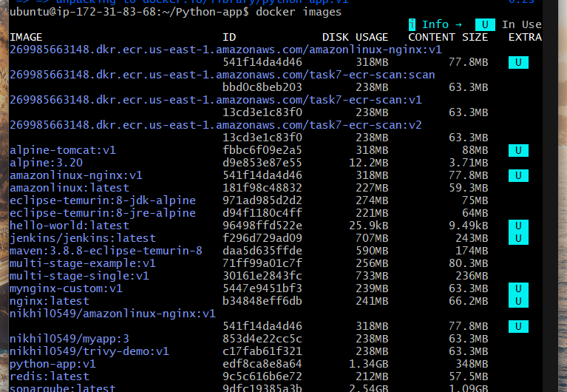

Step 7 — Run Docker Container
docker run -d --name python-app -p 8085:8080 python-app:v1
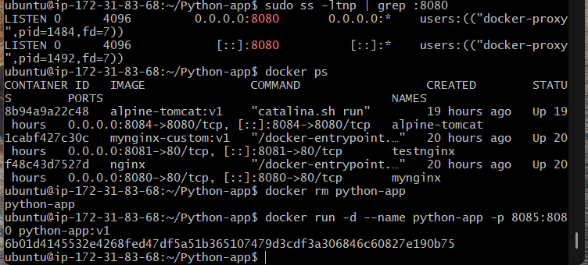

Step 8 — Verify Container
docker ps
The container should be in the Up state.
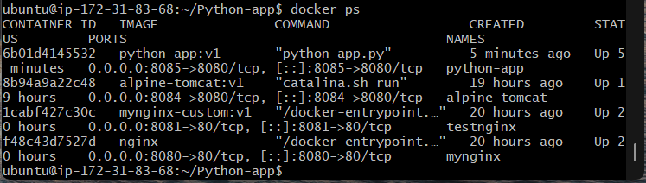

Step 9 — Test the Application
curl http://localhost:8085
If the application is accessible, the Docker container is working successfully.
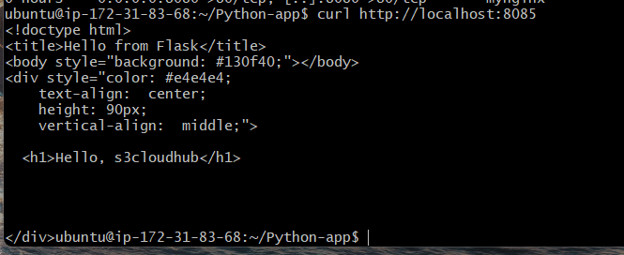

Result
The Python Flask application was successfully containerized using a customized Dockerfile. The Docker image python-app:v1 was built successfully and the application was deployed and tested inside a Docker container on port 8085.
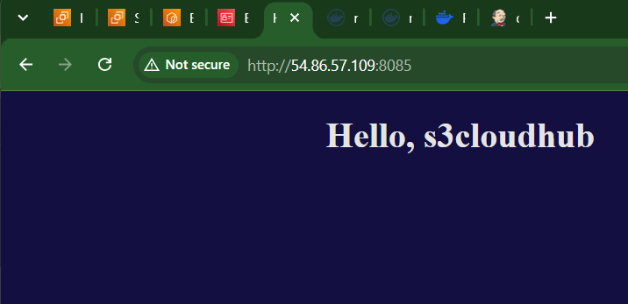

Challenge 2 — Push the Image to Docker Hub
You already have the image:
python-app:v1
Now we'll push it to Docker Hub.

Step 1 — Check your image
docker images
You should have:
python-app v1
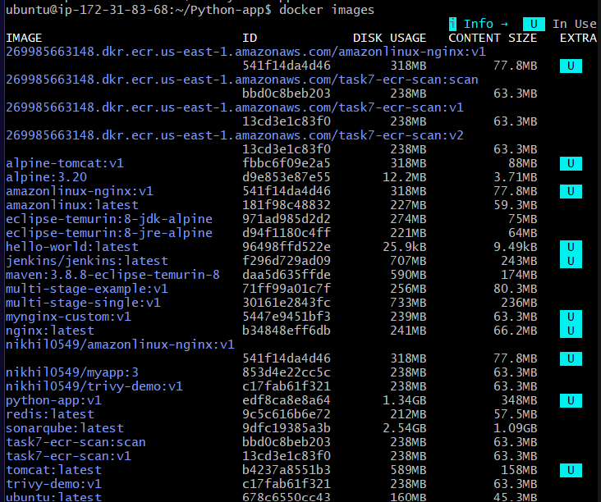

Step 2 — Login to Docker Hub
docker login
Enter your Docker Hub username and password/PAT when prompted.
Successful login should show:
Login Succeeded

Step 3 — Tag the image
Docker Hub requires the image name to contain your Docker Hub username.
Replace <username> with your Docker Hub username:
docker tag python-app:v1 <username>/python-app:v1
For example, if your username is nikhil:
docker tag python-app:v1 nikhil/python-app:v1
Check:
docker images
You should now see both:
python-app v1
<username>/python-app v1
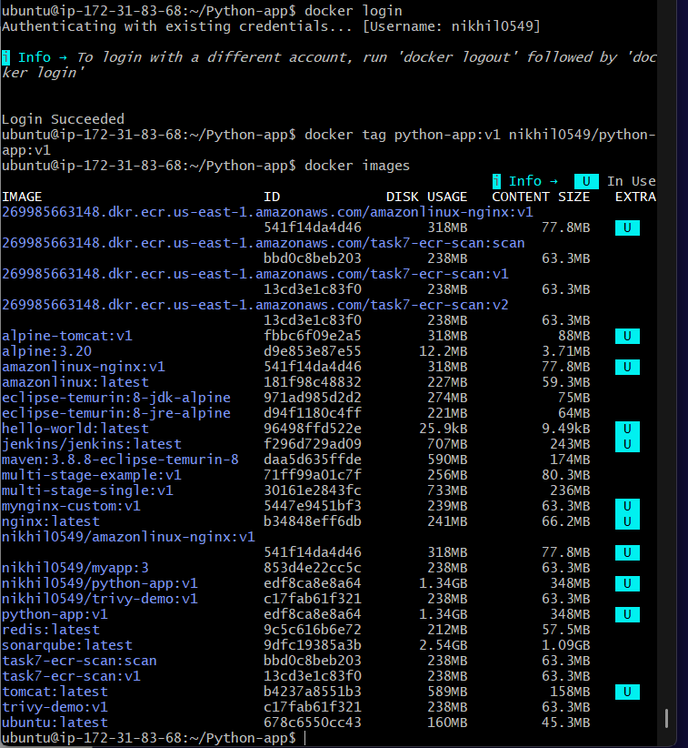

Step 4 — Push the image
docker push <username>/python-app:v1
Example:
docker push nikhil/python-app:v1
You should eventually see:
v1: digest: sha256:...
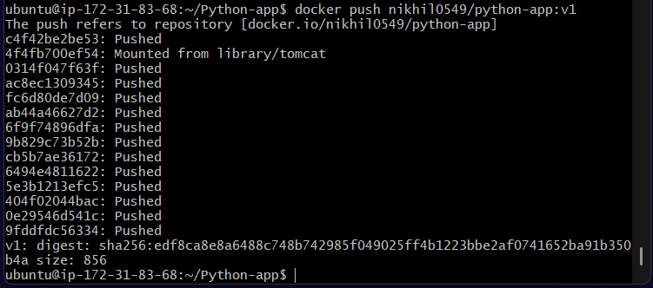

Step 5 — Verify in Docker Hub
Open Docker Hub and check your repository.
You should have:
Repository: python-app
Tag: v1
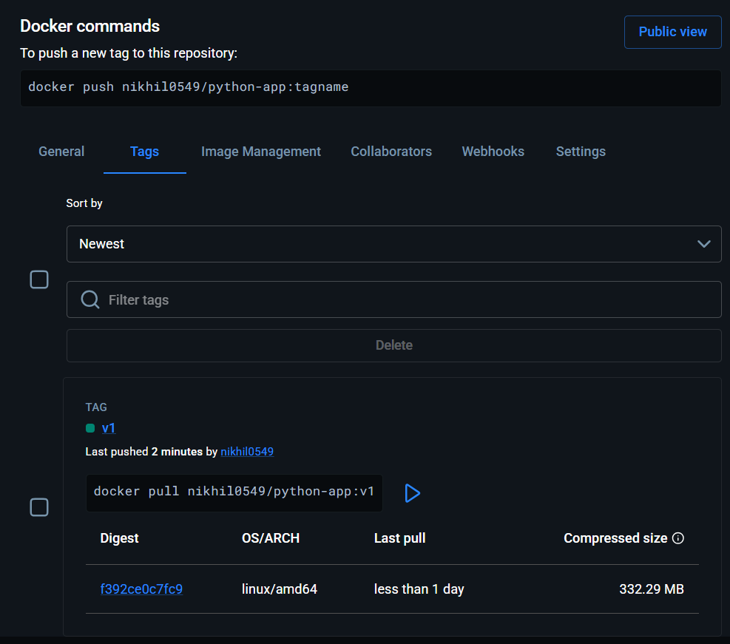

Challenge 3 — Push the Same Image to Amazon ECR
We will push the same python-app:v1 image to ECR.
First, verify AWS CLI access:
aws sts get-caller-identity

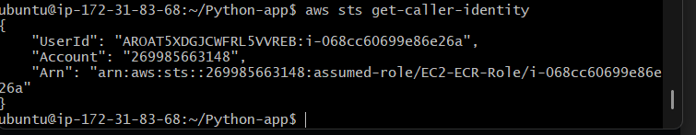

Step 1 — Create an ECR repository
From your current directory, run:
aws ecr create-repository \
--repository-name python-app \
--region us-east-1
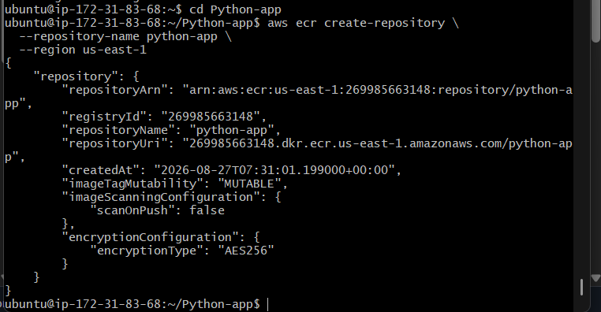

Step 2 — Login Docker to ECR
aws ecr get-login-password --region us-east-1 | \
docker login \
--username AWS \
--password-stdin 269985663148.dkr.ecr.us-east-1.amazonaws.com
Expected:
Login Succeeded

Step 3 — Tag the same image
You already have:
python-app:v1
Tag it for ECR:
docker tag python-app:v1 \
269985663148.dkr.ecr.us-east-1.amazonaws.com/python-app:v1
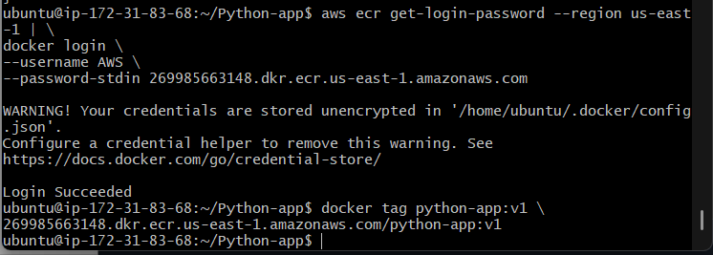
Verify:
docker images
You should see the ECR-tagged image.
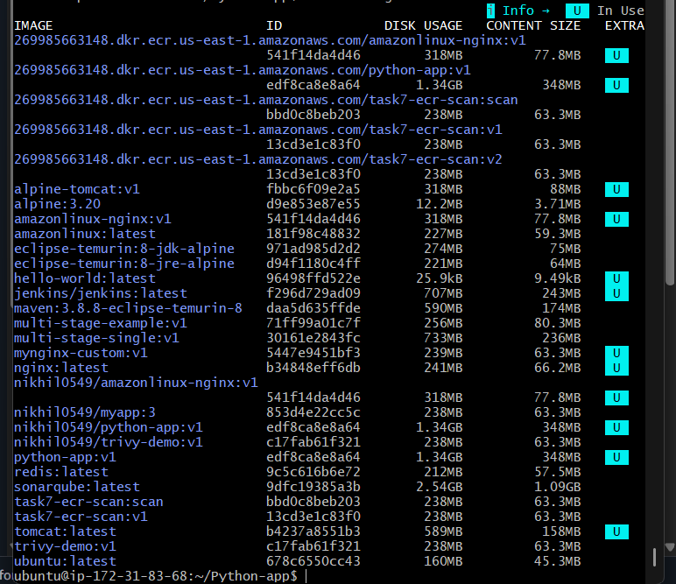

Step 4 — Push to ECR
docker push \
269985663148.dkr.ecr.us-east-1.amazonaws.com/python-app:v1
Wait for the push to complete.
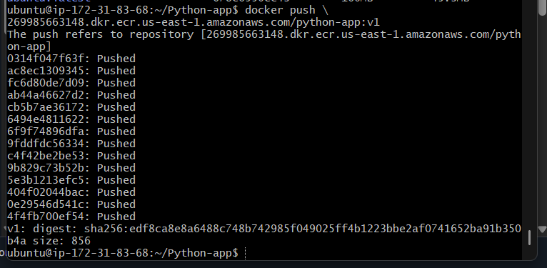

Step 5 — Verify in ECR
AWS Console:
ECR
→ Repositories
→ python-app
→ Images
You should see:
Tag: v1
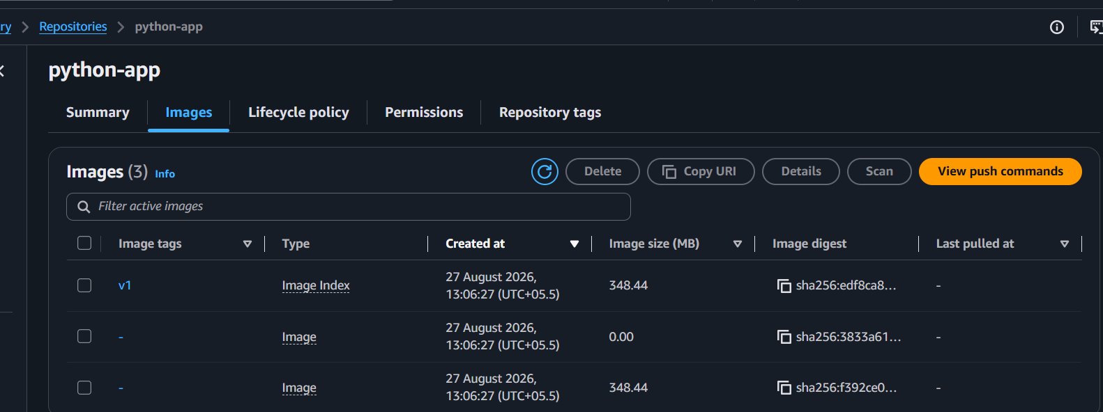

Challenge 4 — Provision an EC2 Instance Using Terraform and Install Jenkins

Goal
Create one new EC2 instance using Terraform and install Jenkins on that instance.
Terraform
↓
Security Group
↓
EC2 Instance
↓
Java 21
↓
Jenkins
↓
Jenkins :8080
Your current EC2 is only being used as the Terraform execution machine. The new EC2 will become the Jenkins server.

Step 1 — Verify Terraform
You already completed this:
terraform --version
Output:
Terraform v1.16.0
✅ Terraform installed.

Step 2 — Create Terraform directory
mkdir ~/terraform-jenkins
cd ~/terraform-jenkins
Verify:
pwd
Expected:
/home/ubuntu/terraform-jenkins

Step 3 — Verify AWS access
Run:
aws sts get-caller-identity
You already verified that your current EC2 uses:
EC2-ECR-Role
We have also added EC2 permissions to this role.

Step 4 — Find your existing key pair
Run:
aws ec2 describe-key-pairs \
--region us-east-1 \
--query 'KeyPairs[*].KeyName' \
--output table
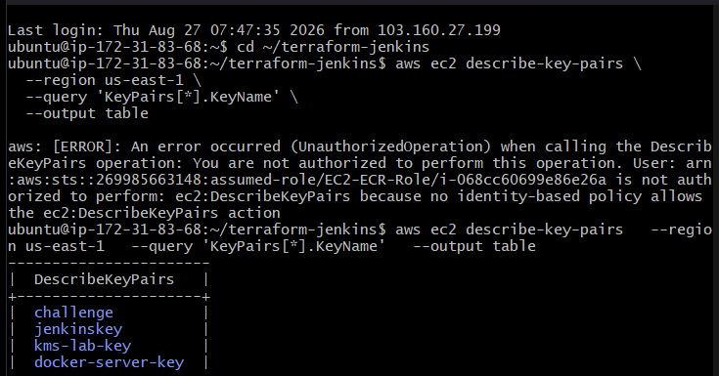

Step 5 — Find the Ubuntu AMI
Run:
aws ec2 describe-images \
--region us-east-1 \
--owners 099720109477 \
--filters \
"Name=name,Values=ubuntu/images/hvm-ssd-gp3/ubuntu-noble-24.04-amd64-server-*" \
"Name=state,Values=available" \
--query 'Images | sort_by(@, &CreationDate)[-1].[ImageId,Name]' \
--output table
You should get something like:
-------------------------------------------------
| DescribeImages |
+----------------------+------------------------+
| ami-xxxxxxxxxxxxxx | ubuntu-24.04... |
+----------------------+------------------------+

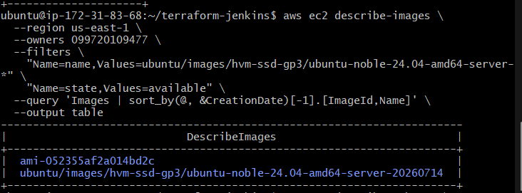The AMI ID will be different depending on the current AWS image.

Step 6 — Find the VPC and subnet
We need a subnet where Terraform will create the new EC2.
Run:
aws ec2 describe-subnets \
--region us-east-1 \
--query 'Subnets[*].[SubnetId,VpcId,AvailabilityZone,MapPublicIpOnLaunch]' \
--output table
We want a public subnet because we need to SSH into the new Jenkins server and access Jenkins from a browser.
Look for a subnet where:
MapPublicIpOnLaunch = True
Also note its:
SubnetId
VpcId
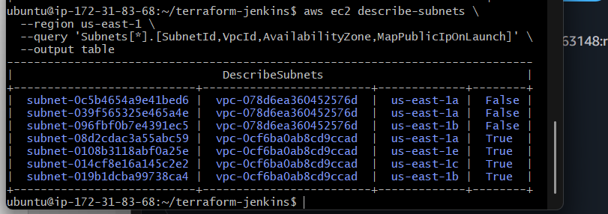

Step 7 — Create main.tf
Create the file:
nano main.tf
Paste this:
terraform {
required_providers {
aws = {
source = "hashicorp/aws"
version = "~> 6.0"
}
}
}

provider "aws" {
region = "us-east-1"
}

resource "aws_security_group" "jenkins_sg" {
name = "jenkins-sg"
description = "Security group for Jenkins server"
vpc_id = "vpc-0cf6ba0ab8cd9ccad"

ingress {
description = "SSH"
from_port = 22
to_port = 22
protocol = "tcp"
cidr_blocks = ["0.0.0.0/0"]
}

ingress {
description = "Jenkins"
from_port = 8080
to_port = 8080
protocol = "tcp"
cidr_blocks = ["0.0.0.0/0"]
}

egress {
from_port = 0
to_port = 0
protocol = "-1"
cidr_blocks = ["0.0.0.0/0"]
}

tags = {
Name = "jenkins-sg"
}
}

resource "aws_instance" "jenkins_server" {
ami = "ami-052355af2a014bd2c"
instance_type = "t3.small"
key_name = "jenkinskey"
subnet_id = "subnet-08d2cdac3a55abc59"

vpc_security_group_ids = [aws_security_group.jenkins_sg.id]

associate_public_ip_address = true

tags = {
Name = "Terraform-Jenkins-Server"
}
}

output "jenkins_public_ip" {
value = aws_instance.jenkins_server.public_ip
}
Save:
Ctrl+O → Enter → Ctrl+X
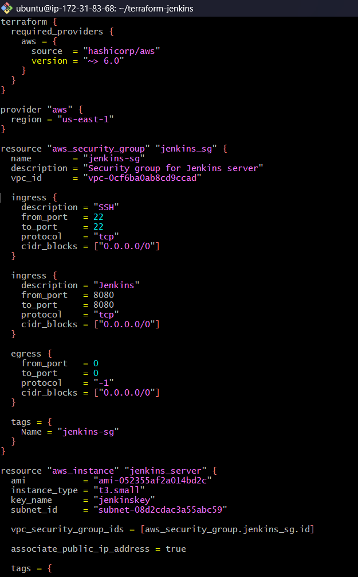

Step 8 — Initialize Terraform
Run:
terraform init
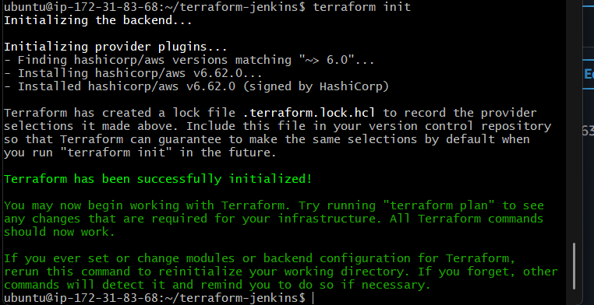
Then:
terraform validate
Then:
terraform plan

This does not create anything. It only shows what Terraform intends to create.
You should see approximately:
Plan: 2 to add, 0 to change, 0 to destroy.
The 2 resources are:
aws_security_group.jenkins_sg
aws_instance.jenkins_server

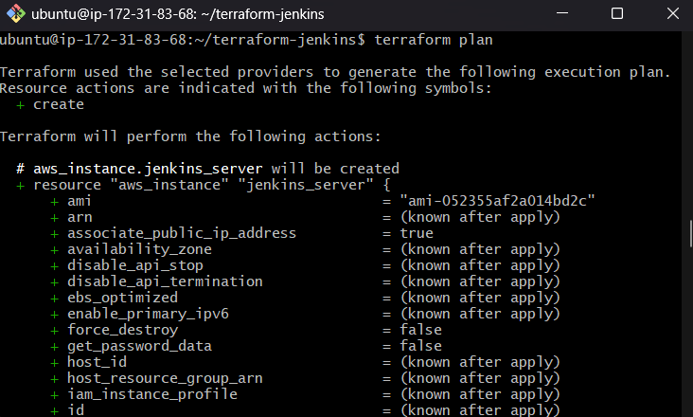

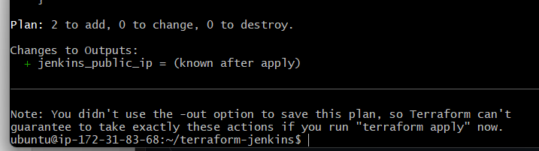

Step 9 — Create the EC2 instance
Run:
terraform apply
Terraform will ask:
Do you want to perform these actions?
Only 'yes' will be accepted to approve.

Enter a value:
Enter:
yes
Wait until you see:
Apply complete! Resources: 2 added, 0 changed, 0 destroyed.
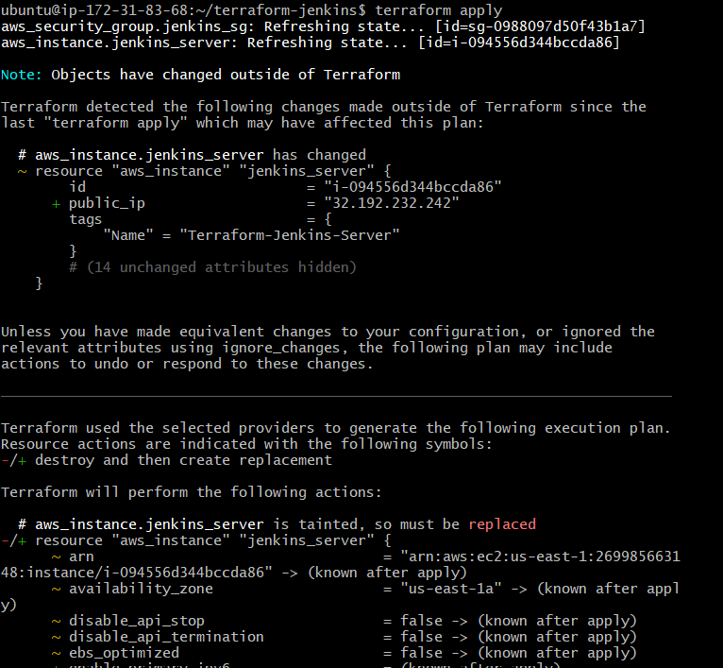
You should also get:
Outputs:

jenkins_public_ip = "YOUR_PUBLIC_IP"
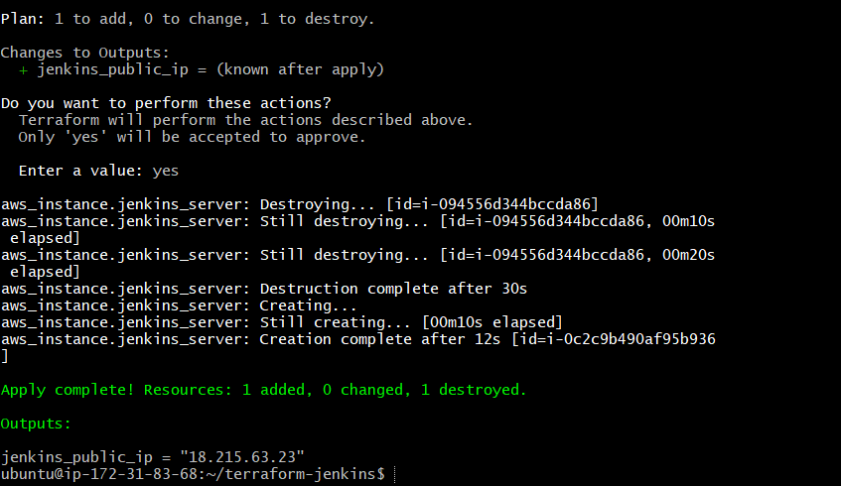

Step 10 — Verify the EC2
After apply succeeds, run:
terraform output
Then:
terraform output jenkins_public_ip
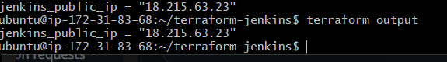
Step 11 — SSH into the new EC2
On your Windows machine, open a new Git Bash.
Go to the folder where your jenkinskey.pem file is located:
cd /path/to/your/key
For example:
cd ~/Downloads
Check:
ls
You should see:
jenkinskey.pem
Then set the permission:
chmod 400 jenkinskey.pem
Now SSH to your Terraform-created EC2:
ssh -i jenkinskey.pem ubuntu@18.215.63.23
You may get:
Are you sure you want to continue connecting (yes/no/[fingerprint])?
Enter:
yes
If successful, your prompt will change from something like:
nikhil@Windows MINGW64
to:
ubuntu@ip-172-31-xx-xx:~$
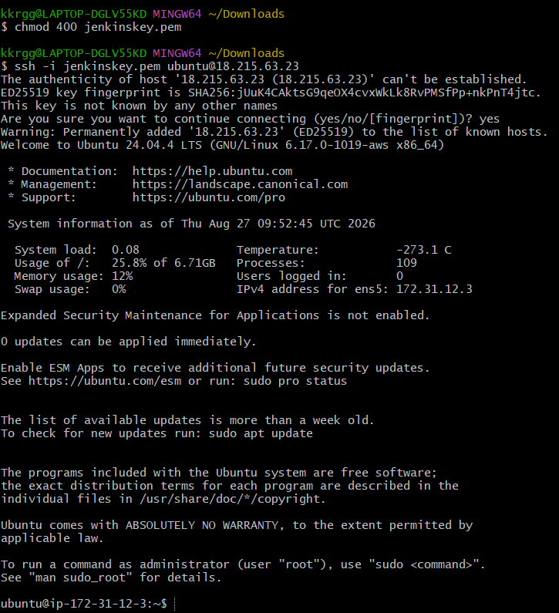

Step 12 — Update the packages
On the new Jenkins EC2, run:
sudo apt update
Then:
sudo apt upgrade -y

Step 13 — Install Java 21
Jenkins requires Java. We'll use OpenJDK 21.
Run:
sudo apt install openjdk-21-jdk -y
Then verify:
java -version
You should see something similar to:
openjdk version "21.x.x"
Also verify the compiler:
javac -version
Expected:
javac 21.x.x

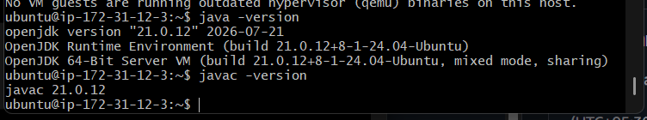

Step 14 — Install Jenkins
First add the Jenkins repository key:
sudo wget -O /etc/apt/keyrings/jenkins-keyring.asc \
https://pkg.jenkins.io/debian-stable/jenkins.io-2026.key
Then add the Jenkins repository:
echo "deb [signed-by=/etc/apt/keyrings/jenkins-keyring.asc] https://pkg.jenkins.io/debian-stable binary/" | \
sudo tee /etc/apt/sources.list.d/jenkins.list > /dev/null
Update the package list:
sudo apt update
Install Jenkins:
sudo apt install jenkins -y
Then start Jenkins:
sudo systemctl start jenkins
Enable Jenkins to start automatically after reboot:
sudo systemctl enable jenkins
Check the service:
sudo systemctl status jenkins
You should see:
Active: active (running)
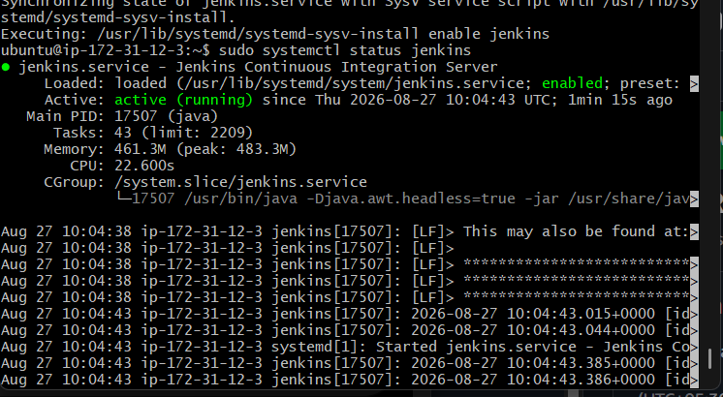

Step 15 — Get the Jenkins initial admin password
Run this on the new Jenkins EC2:
sudo cat /var/lib/jenkins/secrets/initialAdminPassword
You'll get a password similar to:
a8f7c9...

Step 16 — Open Jenkins in your browser
Open:
http://18.215.63.23:8080
You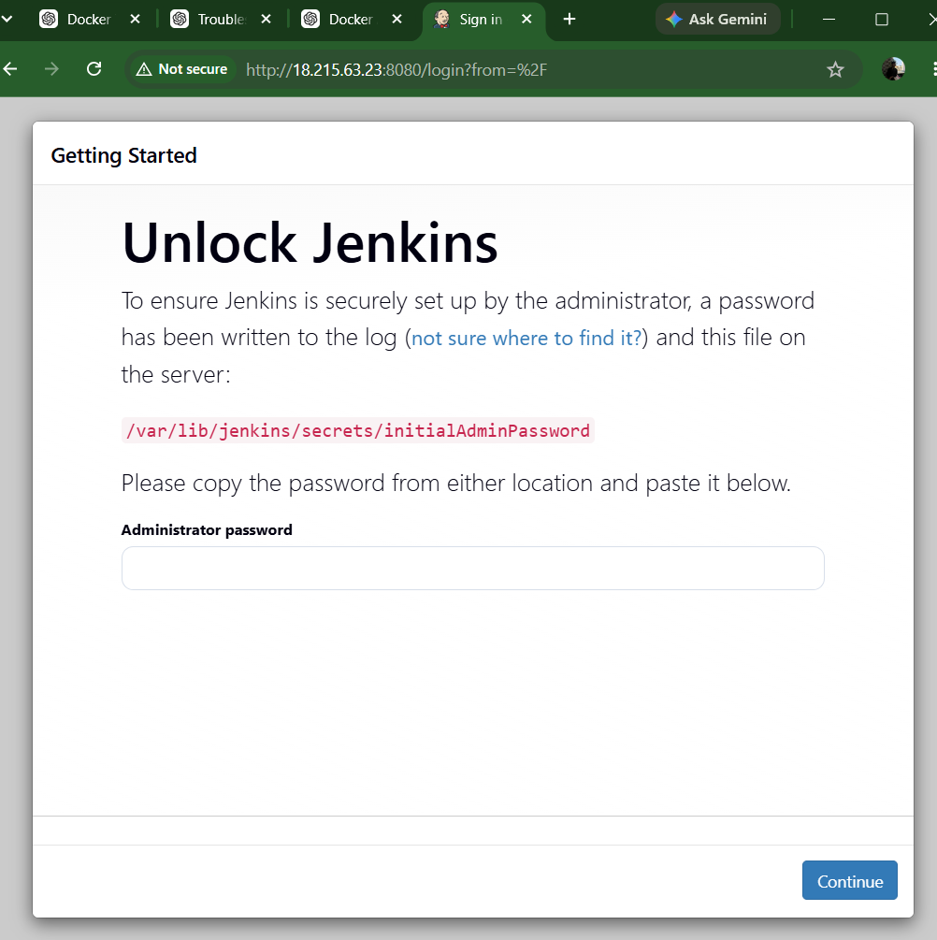 should see the Unlock Jenkins page.
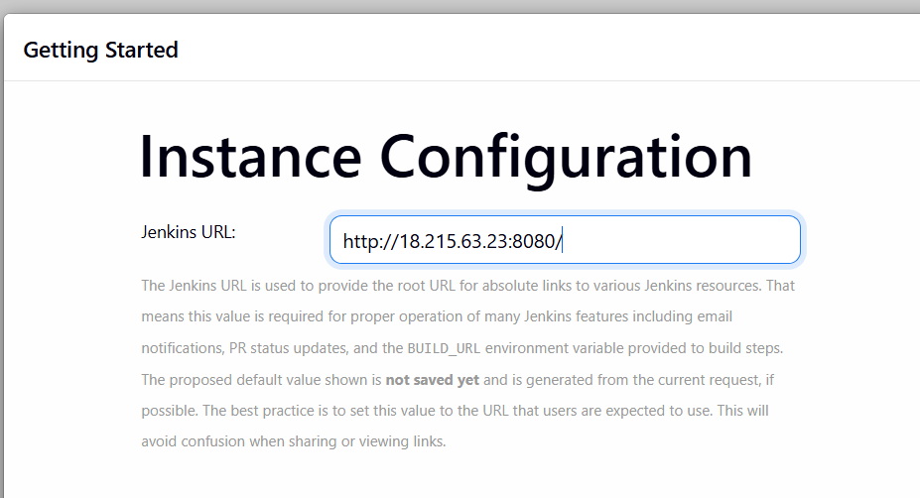
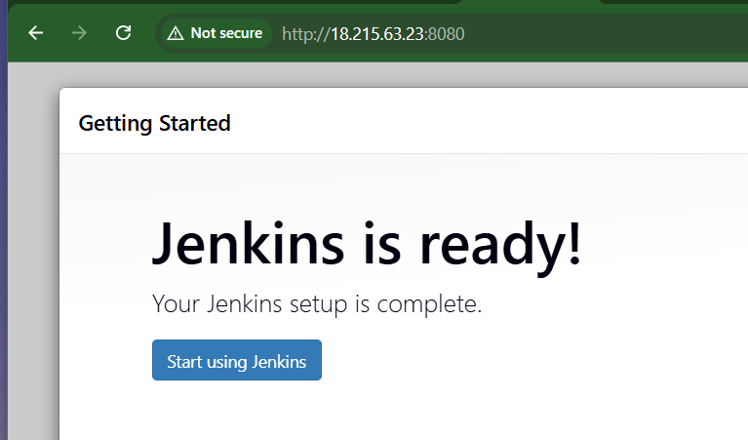

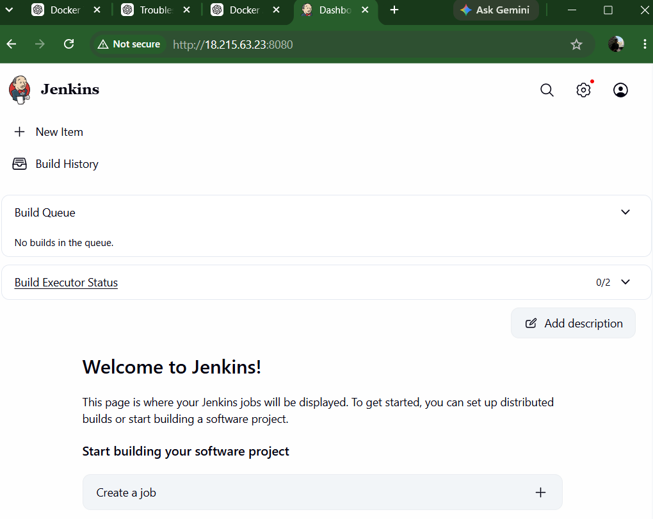

Jenkins Web Access: The Jenkins server was accessed using the EC2 public IP address and port 8080 (http://<Public-IP>:8080). The Jenkins initial administrator password was retrieved from /var/lib/jenkins/secrets/initialAdminPassword, allowing the initial Jenkins setup to be completed.

Challenge 5 — Jenkins Job to Build and Push Docker Image to Docker Hub
We will use our existing source:
https://github.com/betawins/Python-app.git
The flow will be:
GitHub
↓
Jenkins
↓
Clone Python-app
↓
Build Docker Image
↓
Login to Docker Hub
↓
Push Image to Docker Hub
Since Jenkins is now installed on the new EC2, we'll configure everything there.

Step 1 — Verify Docker on Jenkins EC2
On the Jenkins EC2, run:
docker --version
Then:
sudo systemctl status docker

If Docker is not installed
Run:
sudo apt update
sudo apt install docker.io -y
Start Docker:
sudo systemctl start docker
Enable Docker:
sudo systemctl enable docker
Then verify:
docker –version
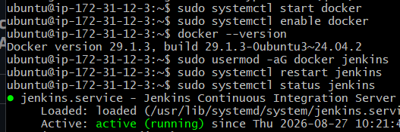

Step 2 — Give Jenkins permission to use Docker
Jenkins runs using the jenkins Linux user. Add it to the Docker group:
sudo usermod -aG docker jenkins
Restart Jenkins:
sudo systemctl restart jenkins
Verify:
sudo systemctl status jenkins
It should show:
Active: active (running)
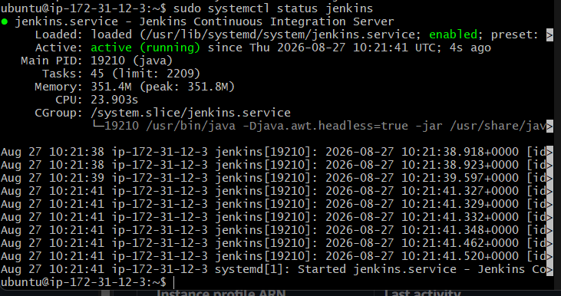

Step 3 — Verify Jenkins can access Docker
Run:
sudo -u jenkins docker --version

Expected
You should get:
Docker version 29.1.3, build ...
This is important because Jenkins will execute the Docker commands, not your ubuntu user.

Step 4 — Verify Git
Run:
git --version
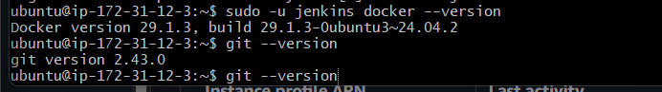

Step 5 — Create Docker Hub Access Token
We need a Docker Hub token because Jenkins should not use your Docker Hub password.
Go to Docker Hub and sign in.
Then:
Account Settings → Personal access tokens → Generate new token
Create a token with permission to Read & Write repositories.
Copy the token immediately because it may only be displayed once.
You will have:
Docker Hub username → your username
Docker Hub token → your generated token
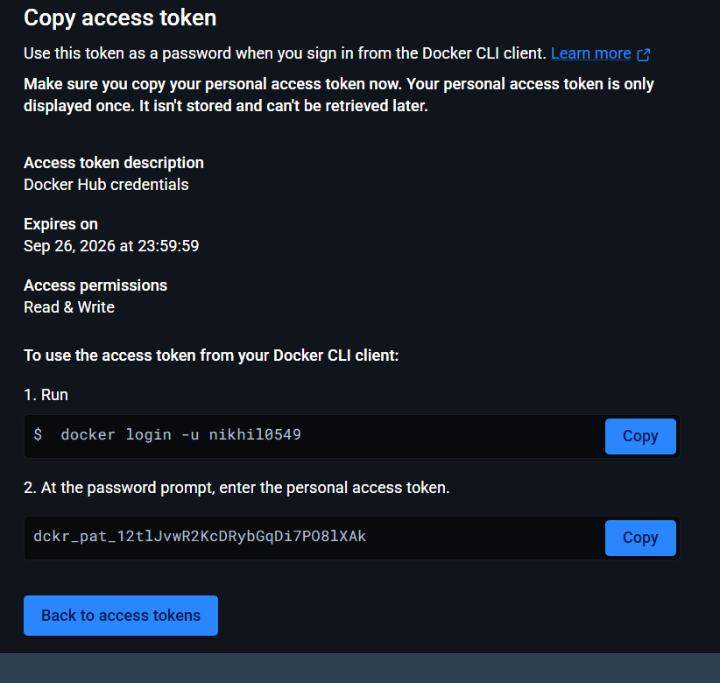

Step 6 — Create Docker Hub credential in Jenkins
Open Jenkins:
http://18.215.63.23:8080
Go to:
Manage Jenkins → Credentials
Then:
System → Global credentials (unrestricted) → Add Credentials
Select:
Kind: Username with password
Scope: Global
Username: <your Docker Hub username>
Password: <Docker Hub access token>
ID: dockerhub-creds
Description: Docker Hub credentials
Click:
Create
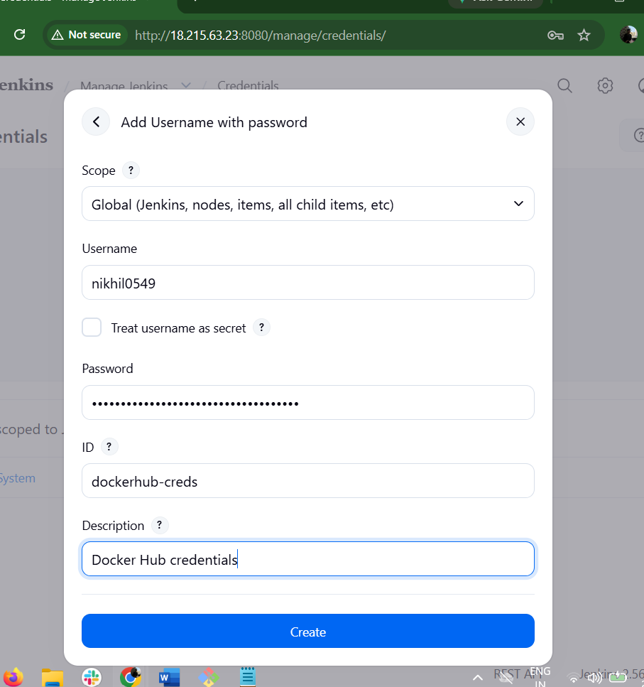

Step 7 — Create Jenkins Pipeline Job
Go to Jenkins:
Dashboard → New Item
Enter:
Name: Python-App-Docker
Select:
Pipeline
Click:
OK

Step 8 — Configure the Pipeline
Scroll down to the Pipeline section.
Set:
Definition: Pipeline script
For now, we'll put the pipeline directly in Jenkins so you can understand each stage.
Use this pipeline:
pipeline {
agent any

stages {

stage('Clone') {
steps {
git 'https://github.com/betawins/Python-app.git'
}
}

stage('Build Docker Image') {
steps {
sh 'docker build -t python-app:v1 .'
}
}

stage('Docker Hub Login') {
steps {
withCredentials([
usernamePassword(
credentialsId: 'dockerhub-creds',
usernameVariable: 'DOCKER_USERNAME',
passwordVariable: 'DOCKER_PASSWORD'
)
]) {
sh 'echo "$DOCKER_PASSWORD" | docker login -u "$DOCKER_USERNAME" --password-stdin'
}
}
}

stage('Push Docker Image') {
steps {
withCredentials([
usernamePassword(
credentialsId: 'dockerhub-creds',
usernameVariable: 'DOCKER_USERNAME',
passwordVariable: 'DOCKER_PASSWORD'
)
]) {
sh 'docker tag python-app:v1 $DOCKER_USERNAME/python-app:v1'
sh 'docker push $DOCKER_USERNAME/python-app:v1'
}
}
}
}
}
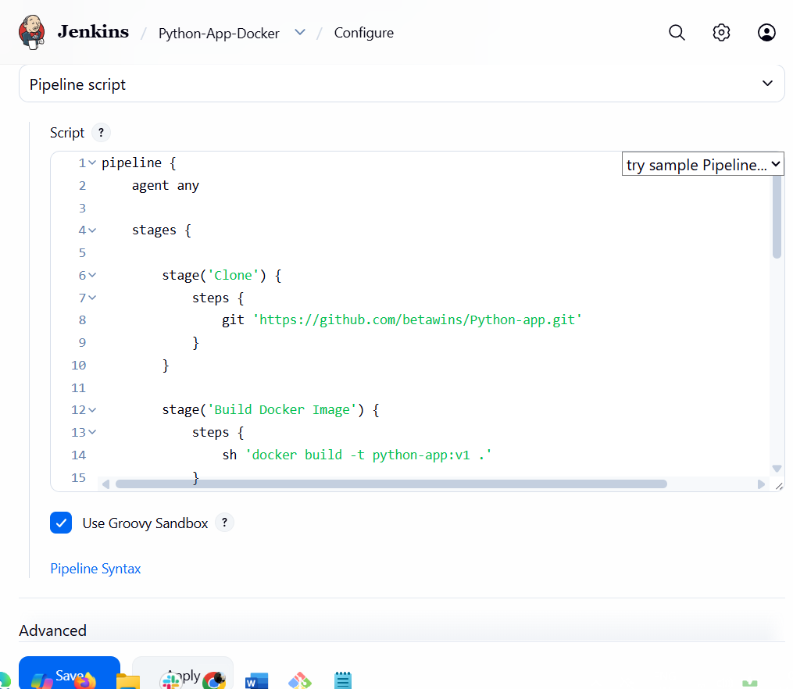

Step 9 — Save
Click:
Save

Step 10 — Run the Jenkins job
In your Jenkins job:
Python-App-Docker → Build Now
A new build will appear on the left, for example:
#1
Click the build number:
#1 → Console Output

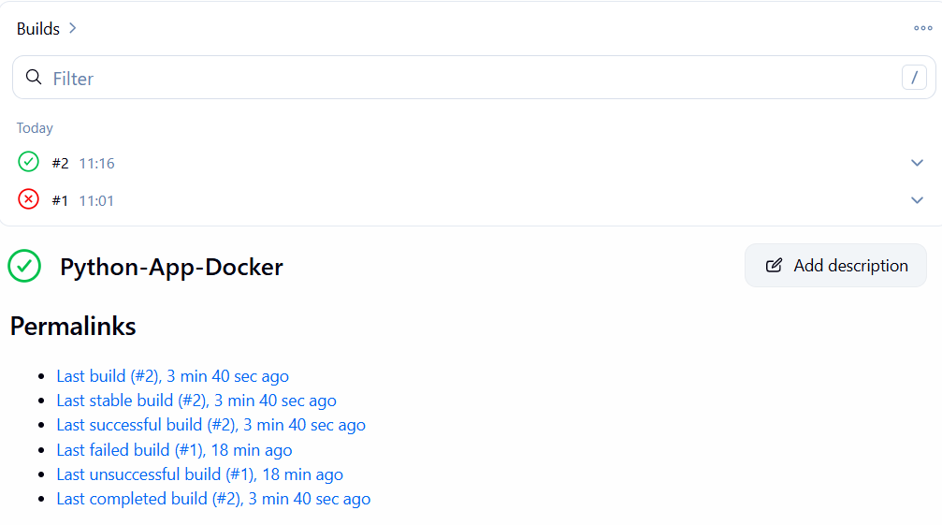

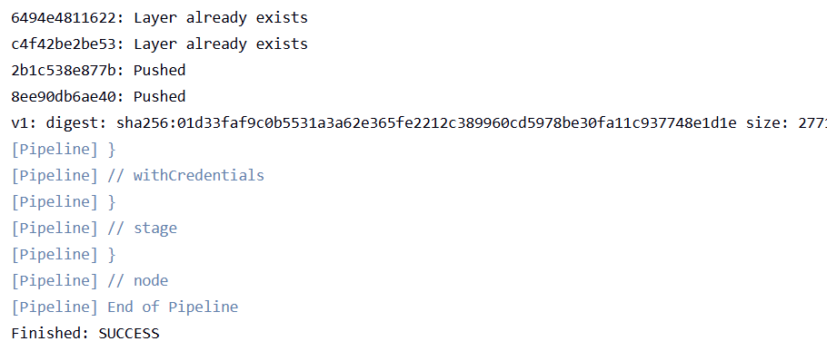
The pipeline should execute:
Clone
↓
Build Docker Image
↓
Docker Hub Login
↓
Push Docker Image

What you should look for
During Build Docker Image, you should see Docker building:
docker build -t python-app:v1 .
During Docker Hub Login:
Login Succeeded
During Push Docker Image, you should see something similar to:
docker push ...
v1: digest: sha256:...
And finally:
Finished: SUCCESS

Step 12 — Verify the image in Docker Hub
Open Docker Hub and go to your repository:
<your-dockerhub-username>/python-app
You should see the image tag:
v1
You can also verify directly from the Jenkins EC2:
docker images
You should see:
python-app v1
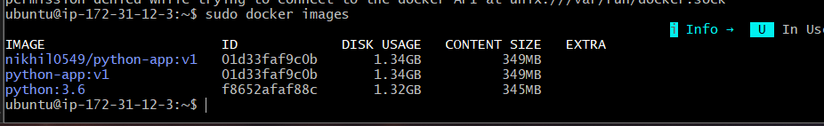
And verify Docker Hub has the image:
docker pull <your-dockerhub-username>/python-app:v1
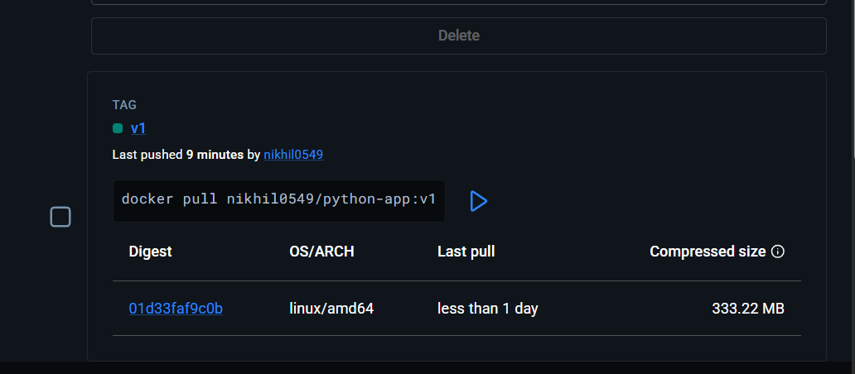
If the pull succeeds, the image is definitely available in Docker Hub.

Frontend Docker Image
We will do this in order:
Frontend source
↓
Understand application
↓
Create Dockerfile
↓
Build image
↓
Run container
↓
Test application
↓
Push to Docker Hub

Step 1 — Clone the source repository
On your working EC2:
cd ~
git clone https://github.com/betawins/docker-tasks.git
cd docker-tasks
Verify:
pwd
ls -la

Find the frontend source
Run:
find . -maxdepth 3 -type f
This is important because we should not assume which directory is the frontend or what technology it uses.
Look for directories/files such as:
frontend/
package.json
index.html
src/

Show the directory structure
Also run:
find . -maxdepth 2 -type d
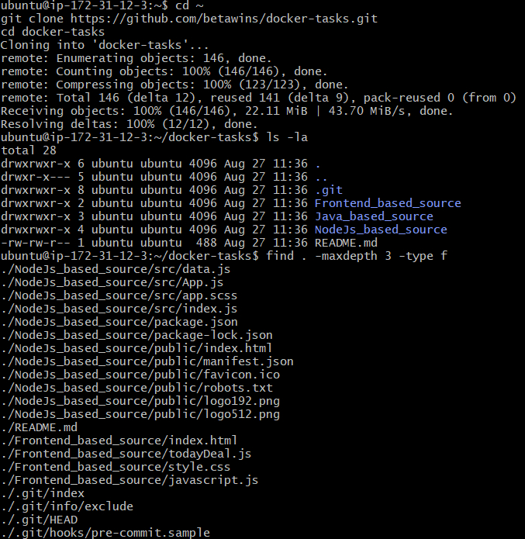

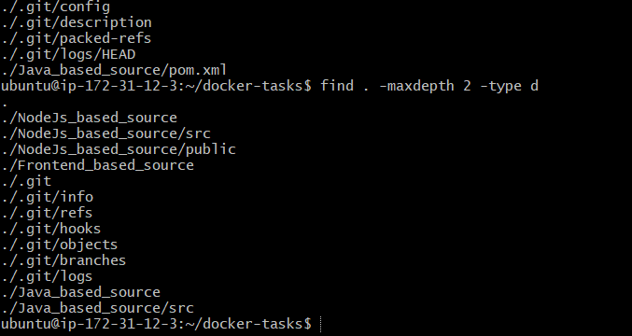
Step 2 — Inspect the frontend
First enter the directory:
cd ~/docker-tasks/Frontend_based_source
Check the files:
ls -la
Now inspect the HTML:
cat index.html
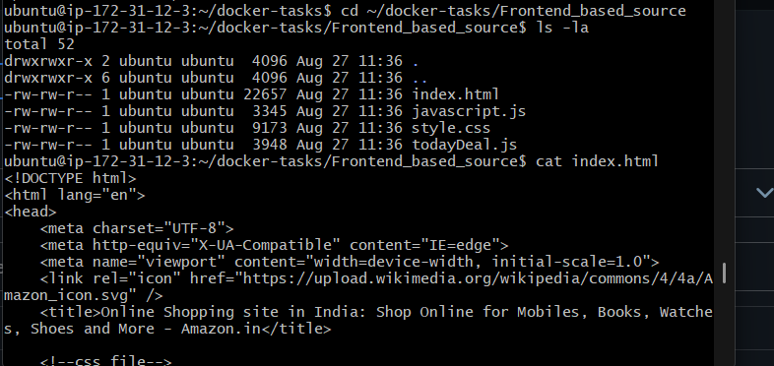
Also check whether the HTML references the CSS and JavaScript files:
grep -E 'css|js' index.html
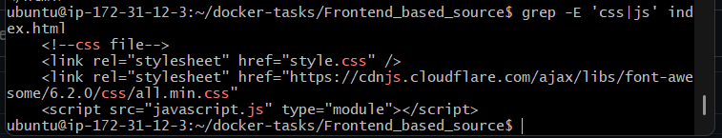

Why are we checking this?
Before creating a Dockerfile, we need to understand how the application runs.
Here, the application is static:
HTML
↓
CSS
↓
JavaScript
↓
Browser
There is no application server that we need to install. Nginx can serve these files.

Step 3 — Create the Dockerfile
After inspecting the files, create:
nano Dockerfile
Add the first instruction:
FROM nginx:latest

Why FROM?
FROM specifies the base image for our Docker image.
Here:
nginx:latest
means Docker will use the official Nginx image as the starting point.
Our frontend contains only:
HTML + CSS + JavaScript
so we don't need Python, Java, or Node.js to run it. Nginx can directly serve these static files.

Step 4 — Copy frontend files
Under the FROM line, add:
COPY . /usr/share/nginx/html/

Why COPY?
COPY copies files from the build context on the host into the Docker image.
Because you're running the build from:
~/docker-tasks/Frontend_based_source
the . means:
Frontend_based_source/
├── index.html
├── todayDeal.js
├── style.css
├── javascript.js
└── Dockerfile
These files will be copied into:
/usr/share/nginx/html/
This is Nginx's default directory for static web content.

Step 5 — Expose the web port
Add:
EXPOSE 80

Why EXPOSE 80?
Nginx listens on port 80 inside the container.
EXPOSE 80 documents that the application expects traffic on container port 80.
Save and exit

Your Dockerfile should now contain:
FROM nginx:latest

COPY . /usr/share/nginx/html/

EXPOSE 80
Save it and run:
cat Dockerfile

We'll use Nginx as the web server.
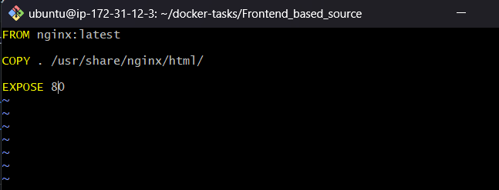

Step 6 — Build the Docker image
Make sure you are still here:
cd ~/docker-tasks/Frontend_based_source
Now build the image:
docker build -t frontend-app:v1 .

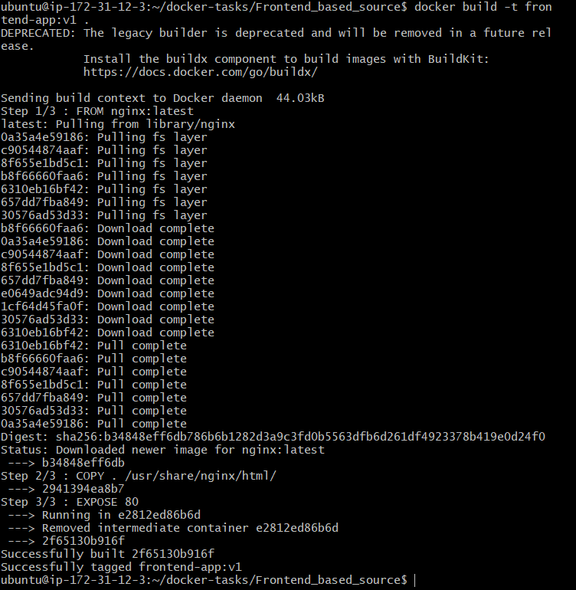

Step 7 — Verify the image
Run:
docker images
You should see:
frontend-app v1
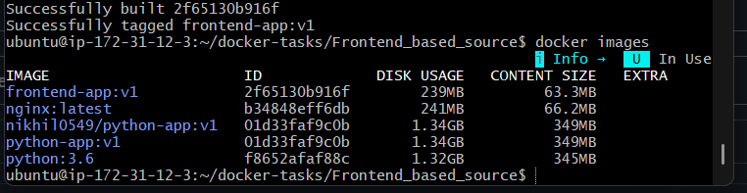

Step 8 — Run the frontend container
Run:
docker run -d --name frontend-app -p 8081:80 frontend-app:v1

What this means
-d
Runs the container in the background.
--name frontend-app
Gives the container the name frontend-app.
-p 8081:80
Maps:
EC2 port 8081 → Container port 80
Nginx listens on 80 inside the container, while we're using 8081 on the EC2 to avoid conflicts with other applications.
frontend-app:v1
Uses the image we just created.
Then verify:
docker ps
You should see something similar to:
0.0.0.0:8081->80/tcp
Run the docker run command and then docker ps.
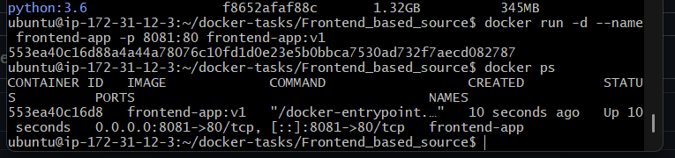

Step 9 — Test the frontend application
First test from the EC2 itself:
curl http://localhost:8081

You should receive the HTML content of your frontend application.
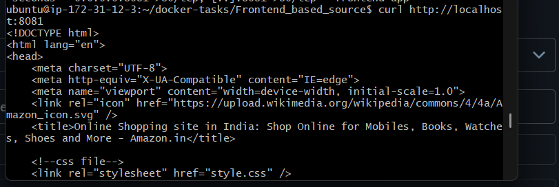Then, to access it from your Windows browser, open:
http://18.215.63.23:8081
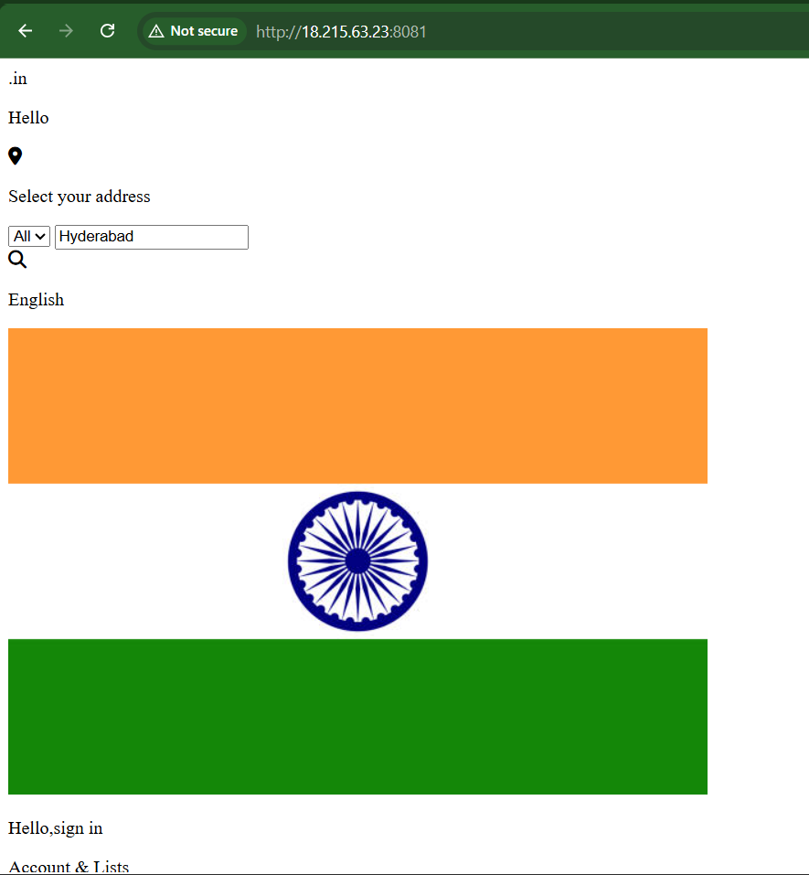

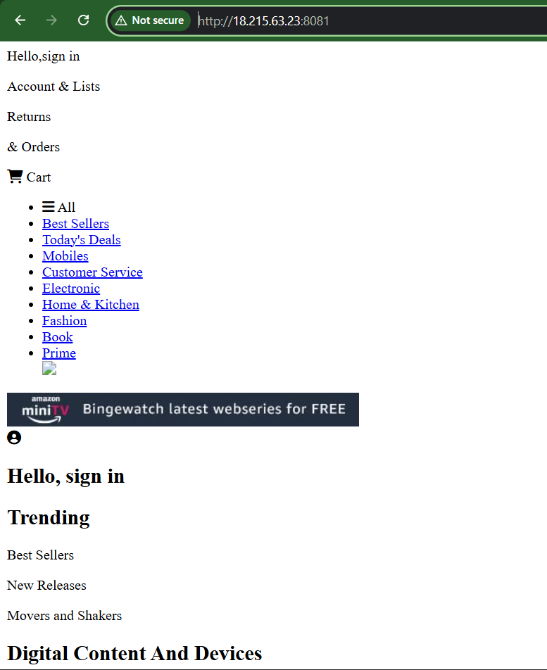

Step 10 — Tag the image for Docker Hub
Your local image is:
frontend-app:v1
Your Docker Hub username is:
nikhil0549
Tag it for Docker Hub:
docker tag frontend-app:v1 nikhil0549/frontend-app:v1
Verify:
docker images
You should see both:
frontend-app v1
nikhil0549/frontend-app v1

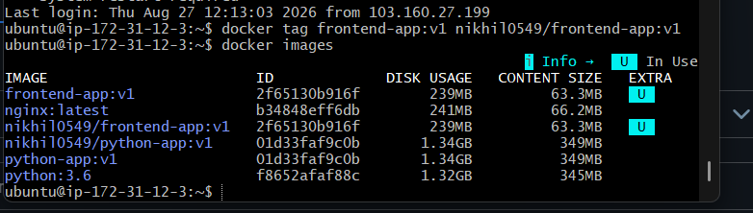

Step 11 — Login to Docker Hub
Run:
docker login
Enter your Docker Hub:
Username: nikhil0549
Password: <Docker Hub access token>
You should get:
Login Succeeded
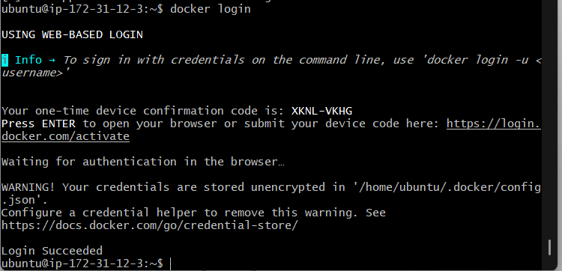

Step 12 — Push image to Docker Hub
Run:
docker push nikhil0549/frontend-app:v1
Docker will upload the image layers.
At the end, you should see something similar to:
v1: digest: sha256:xxxxxxxx...
and the push should complete successfully.
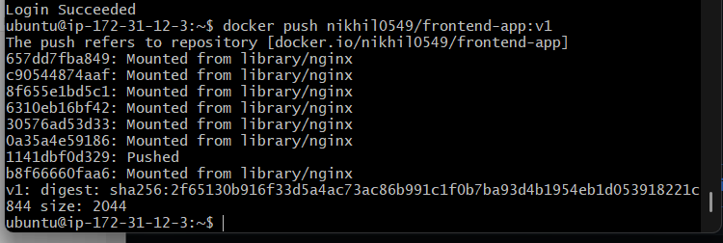

Step 13 — Verify in Docker Hub
Open your Docker Hub account and check:
nikhil0549/frontend-app
You should see:
Tag: v1
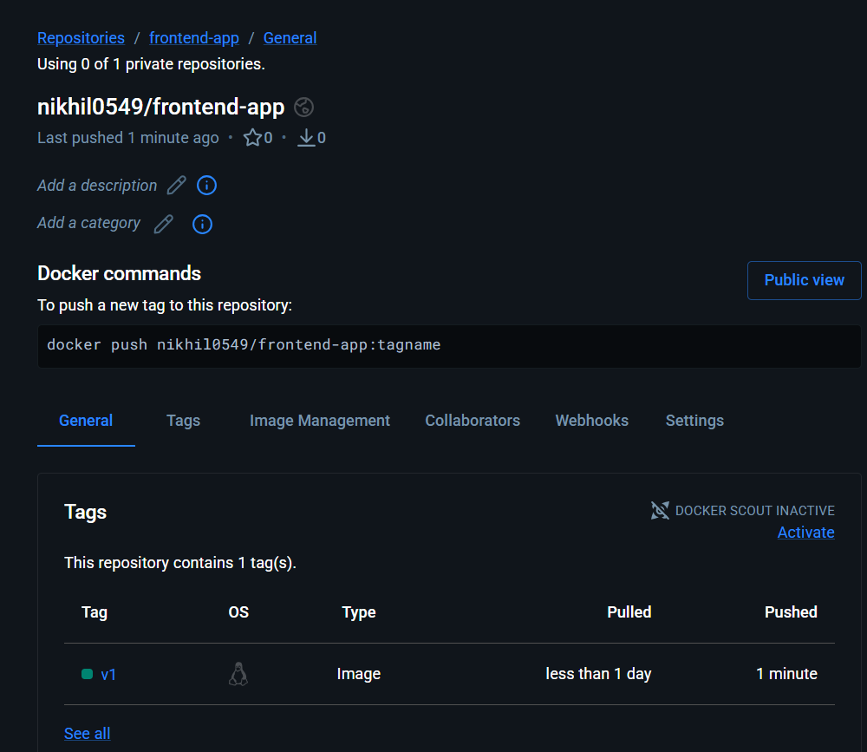

final flow
Frontend source
↓
Dockerfile
↓
docker build
↓
frontend-app:v1
↓
docker run
↓
Frontend tested successfully
↓
Docker Hub login
↓
docker tag
↓
docker push
↓
nikhil0549/frontend-app:v1

Java-based source code.

Flow:

Java source
↓
Understand application
↓
Create Dockerfile
↓
Build image
↓
Run container
↓
Test application
↓
Tag image
↓
Push to Docker Hub

Step 1 — Go to Java source
On the Jenkins EC2:
cd ~/docker-tasks/Java_based_source
Check the files:
ls -la
Then:
find . -maxdepth 3 -type f
You already identified that this directory contains:
Java_based_source/
└── pom.xml
and a src directory.

Step 2 — Understand the Java application
First check the Maven configuration:
cat pom.xml
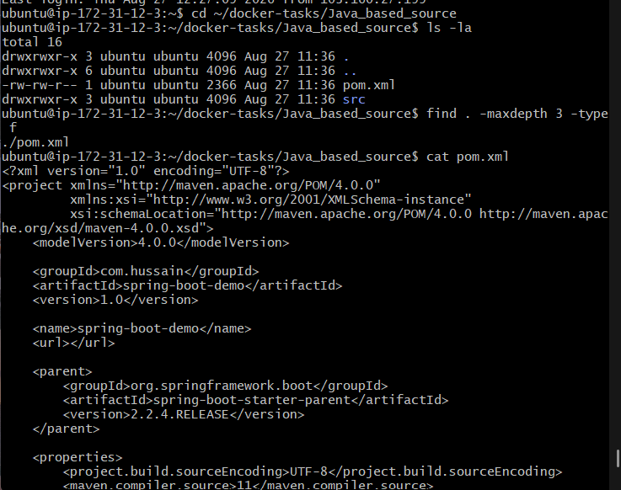
Then check the source files:
find src -type f
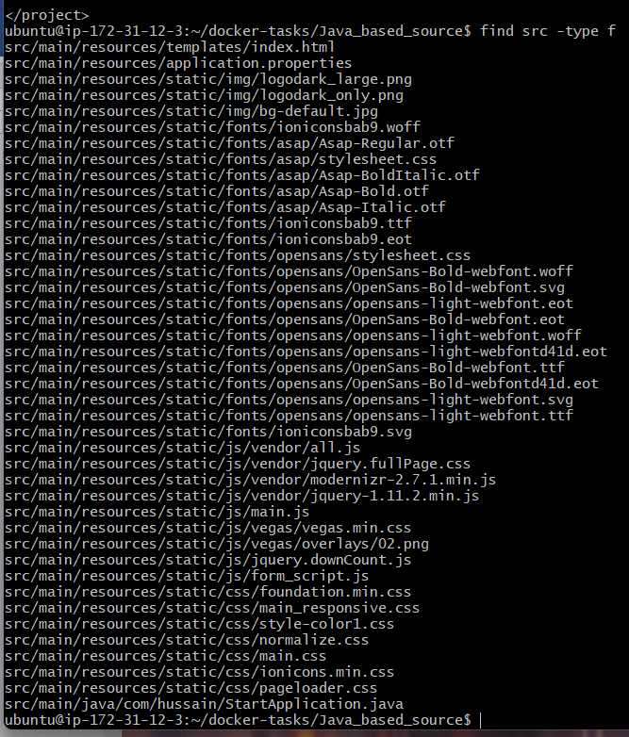
We need to know what type of Java application this is and what port it uses before writing the Dockerfile.

Step 2 — Understand the Java application
This is a Spring Boot web application because pom.xml contains:
spring-boot-starter-web
spring-boot-maven-plugin
The Java version configured in pom.xml is:
Java 11
The main application class is:
src/main/java/com/hussain/StartApplication.java
The application also contains an HTML template:
src/main/resources/templates/index.html

Step 3 — Check the application port
Run:
cat src/main/resources/application.properties
We need to check whether the application explicitly defines a port.
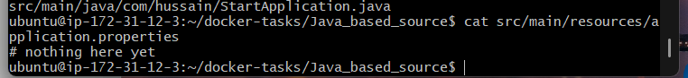

Step 4 — Create the Dockerfile
You are already in:
~/docker-tasks/Java_based_source
Create the file:
nano Dockerfile
Add:
FROM maven:3.8.4-openjdk-11 AS build

WORKDIR /app

COPY pom.xml .
COPY src ./src

RUN mvn clean package -DskipTests

FROM openjdk:11-jre-slim

WORKDIR /app

COPY --from=build /app/target/spring-boot-web.jar .

EXPOSE 8080

ENTRYPOINT ["java", "-jar", "spring-boot-web.jar"]
Save:
Ctrl + O
Enter
Ctrl + X

Step 5 — Verify the Dockerfile
Run:
cat Dockerfile
You should see the Dockerfile contents.
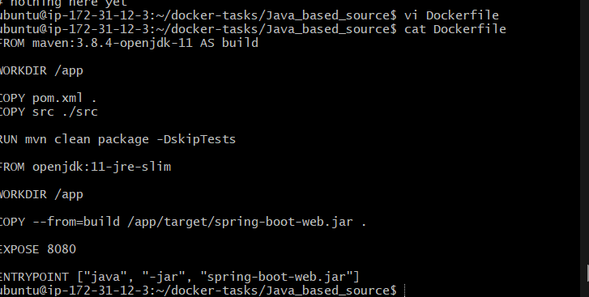

Step 6 — Build the Java Docker image
From the same directory, run:
docker build -t java-app:v1 .
This will:
- Download the Maven/Java 11 build image.
- Copy pom.xml and src.
- Run Maven:
mvn clean package -DskipTests
- Create:
target/spring-boot-web.jar
- Create the smaller runtime image using Java 11.
Run:
docker build -t java-app:v1 .
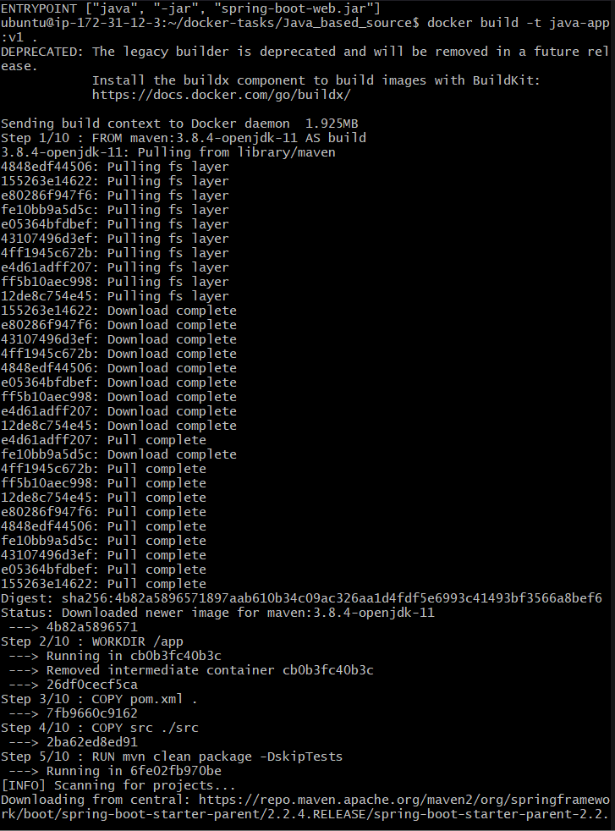

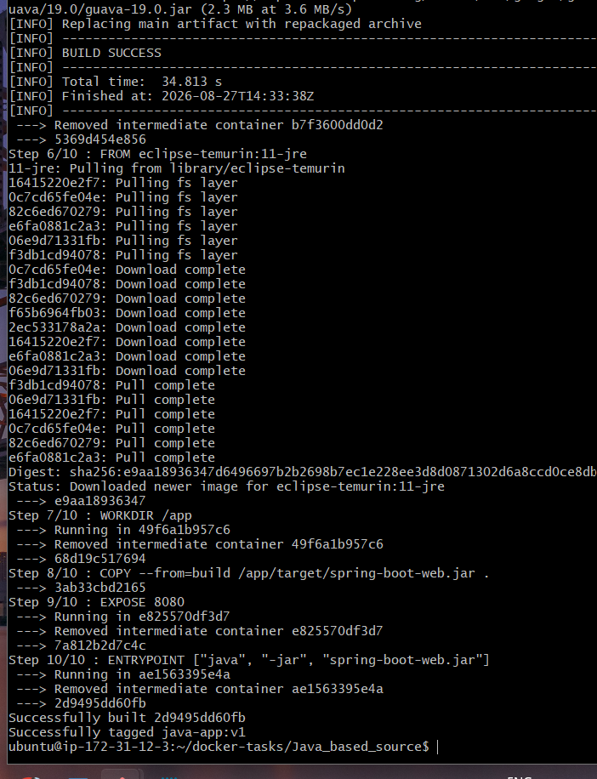

Step 6 — Verify the image
Run:
docker images
You should see:
java-app v1
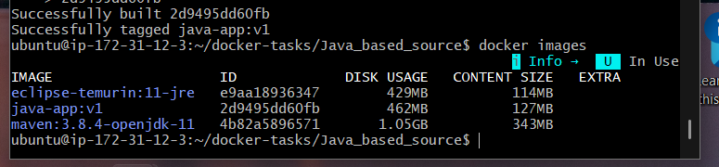

After verification, we'll run the Spring Boot container.

Step 7 — Run the Java container
Run:
docker run -d --name java-app -p 8082:8080 java-app:v1
Then check:
docker ps
You should see something similar to:
java-app:v1 ... 0.0.0.0:8082->8080/tcp
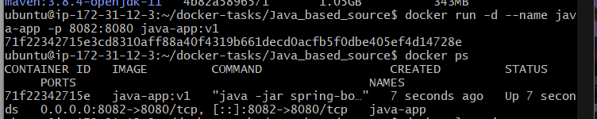

Step 8 — Check the application
First check the container logs:
docker logs java-app
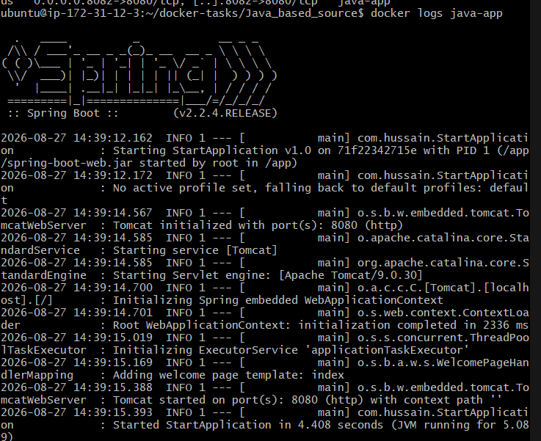
Look for something indicating Spring Boot started successfully, such as:
Started StartApplication
Then test locally:
curl http://localhost:8082
If you get HTML output, the Java application is working.
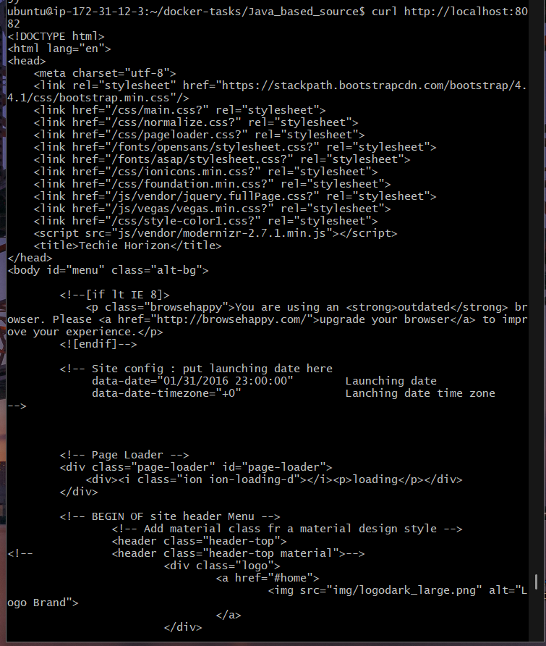
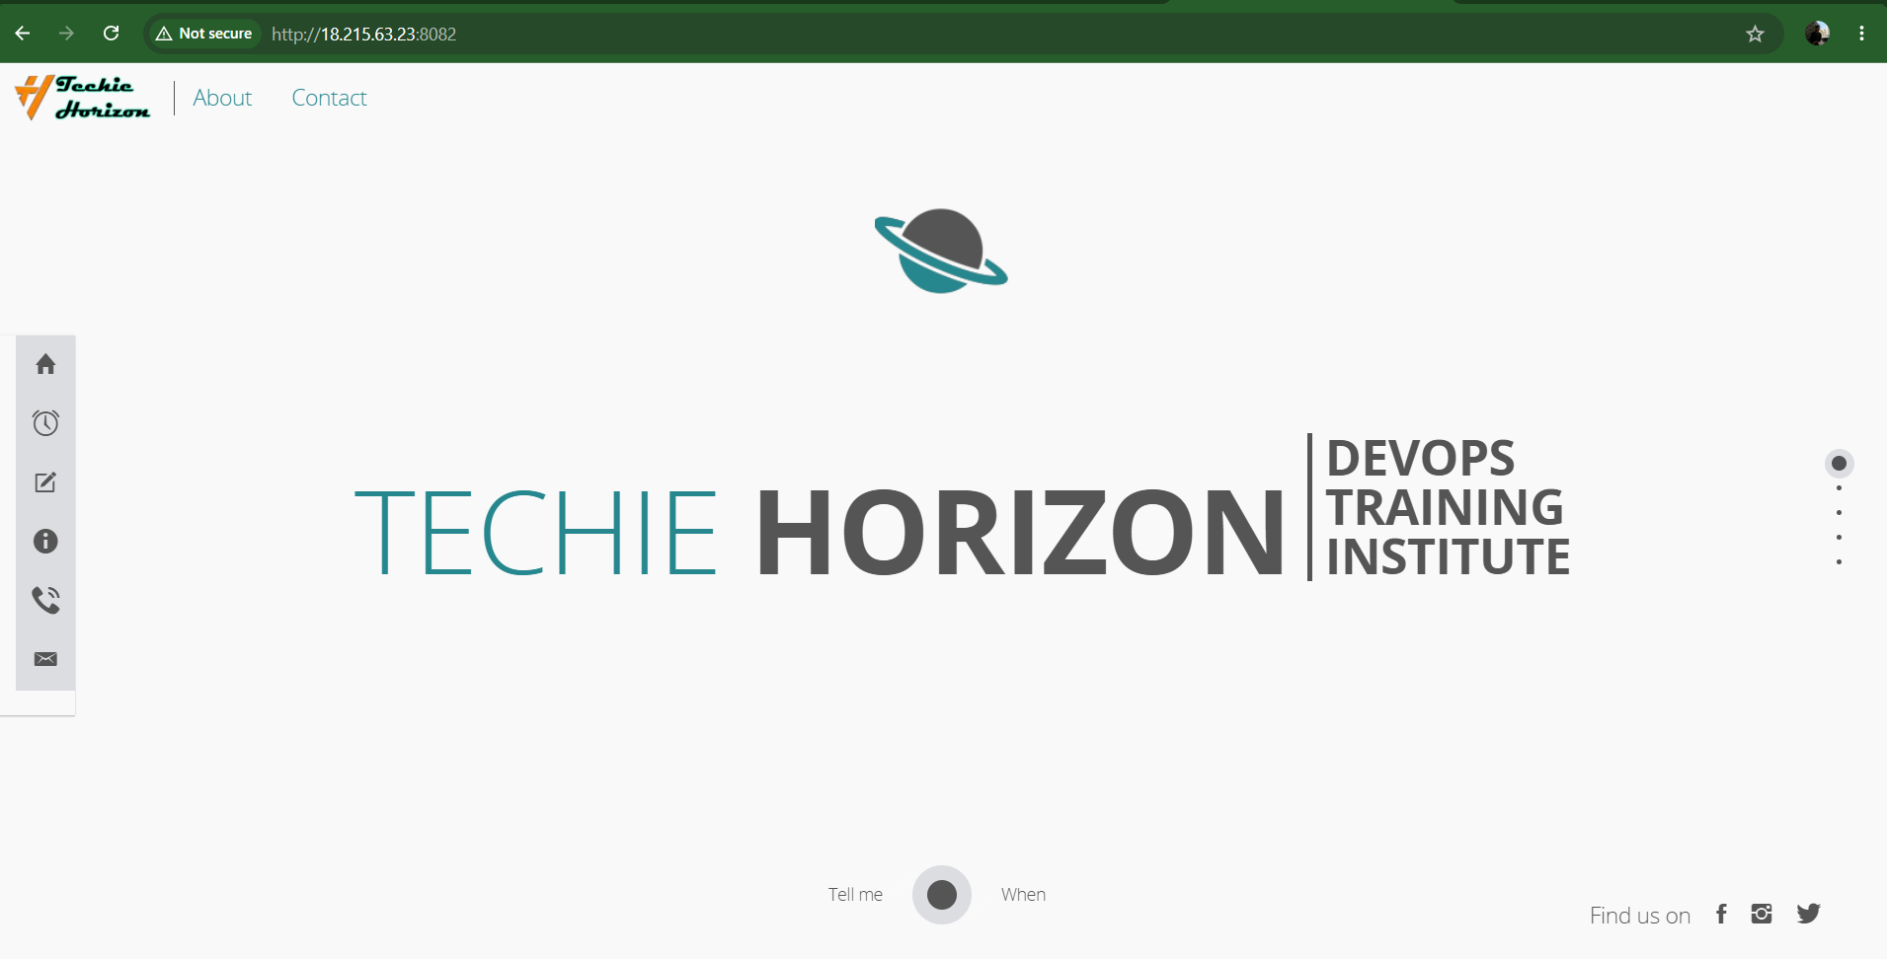

Step 9 — Tag the image
Your local image is:
java-app:v1
Tag it with your Docker Hub username:
docker tag java-app:v1 nikhil0549/java-app:v1
Verify:
docker images
You should see both:
java-app v1
nikhil0549/java-app v1
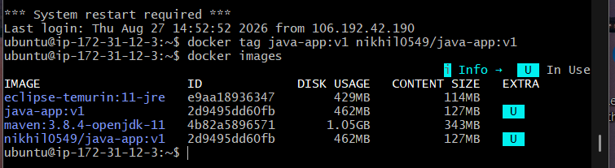
Both tags point to the same image ID.

Step 10 — Push to Docker Hub
You already logged in successfully earlier, so run:
docker push nikhil0549/java-app:v1
You should eventually see:
v1: digest: sha256:...
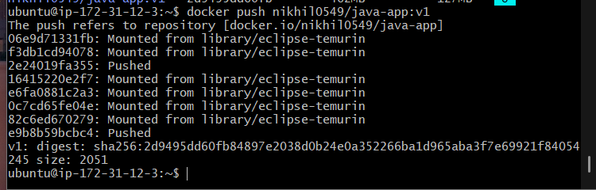

Step 11 — Verify the push
Run:
docker pull nikhil0549/java-app:v1
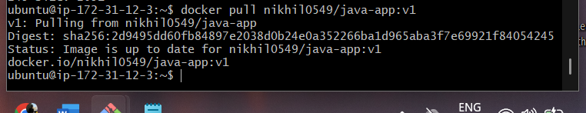

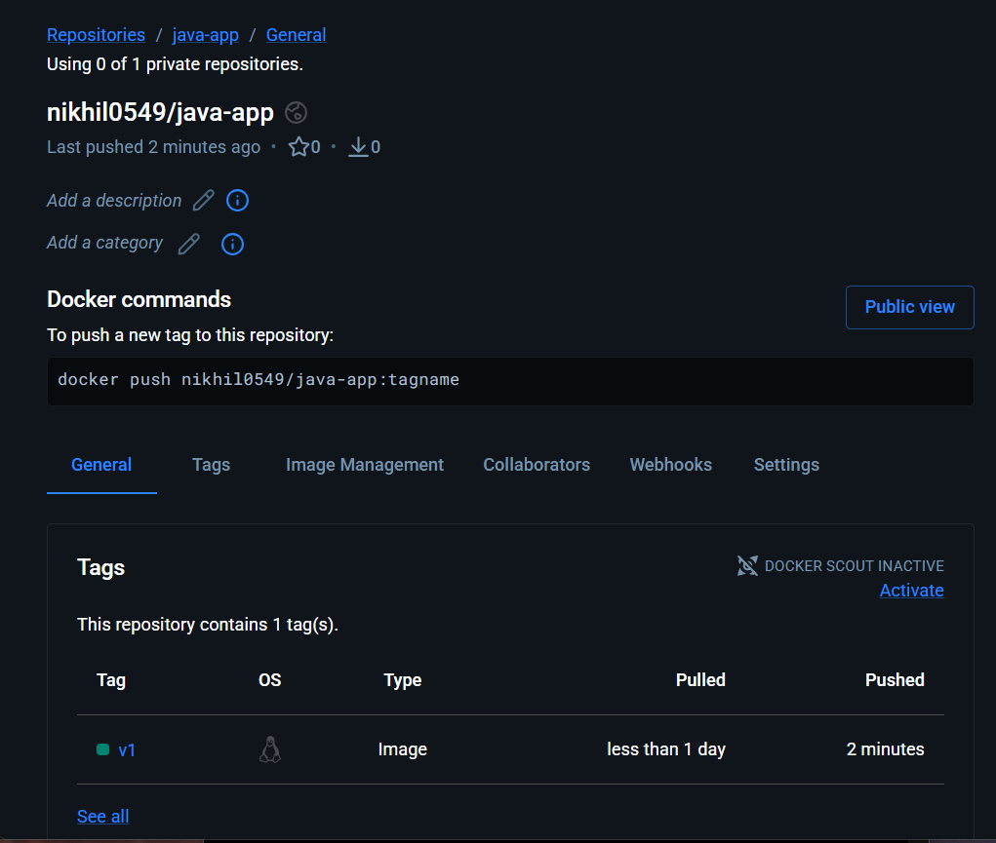

Node.js Application

Step 1 — Go to Node.js source
cd ~/docker-tasks/NodeJs_based_source
Verify:
ls -la
You should see:
package.json
package-lock.json
src
public
Run:
cat package.json
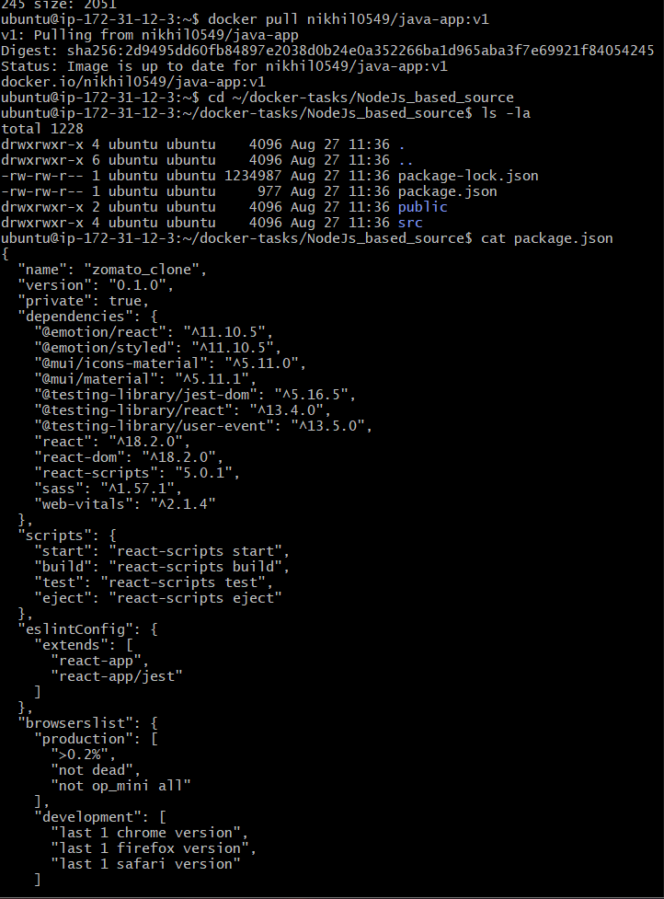
We need to know the exact build command and React version before creating the Dockerfile.

Step 2 — Create the Dockerfile
Create it:
vi Dockerfile
Put this entire content:
FROM node:18-alpine AS build

WORKDIR /app

COPY package*.json ./

RUN npm ci

COPY . .

RUN npm run build

FROM nginx:alpine

COPY --from=build /app/build /usr/share/nginx/html

EXPOSE 80

CMD ["nginx", "-g", "daemon off;"]
Save and exit.

Why we use these stages
Node.js
↓
Install dependencies
↓
npm run build
↓
React production files
↓
Nginx
↓
Serve application on port 80
The final image doesn't contain Node.js or the large node_modules directory, so it is much smaller.

Step 3 — Verify Dockerfile
Run:
cat Dockerfile
You should see exactly the Dockerfile above.
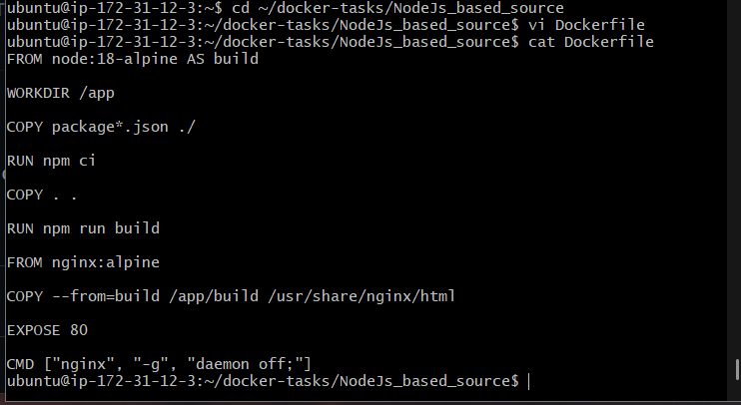

Step 4 — Build with tag v1
This challenge specifically requires the image to be built with tag v1.
Run:
docker build -t node-app:v1 .
This may take a few minutes because npm ci downloads the dependencies.
When it finishes successfully, you should see something similar to:
Successfully built ...
Successfully tagged node-app:v1
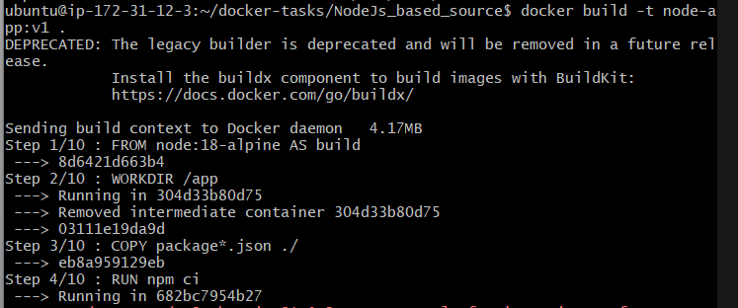

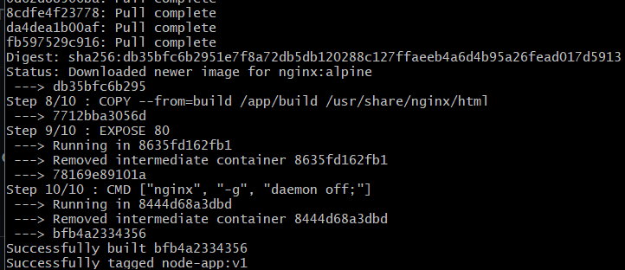
Then verify:
docker images node-app
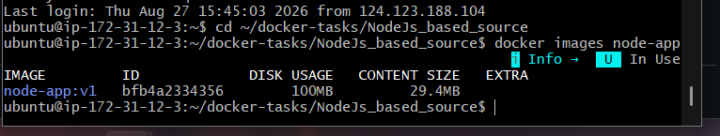

Step 5 — Run the Node.js application
Since your frontend used port 8081 and Java used 8082, let's use 8083 for Node.js.
Run:
docker run -d --name node-app -p 8083:80 node-app:v1
Then check:
docker ps
You should see:
0.0.0.0:8083->80/tcp
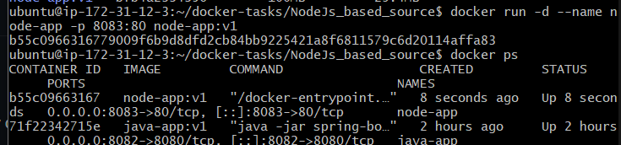

Step 6 — Test the application
First test locally:
curl http://localhost:8083
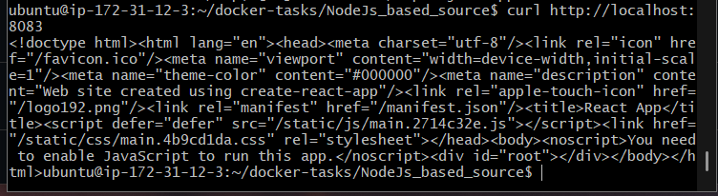
If you get HTML output, test from your browser:
http://<EC2-PUBLIC-IP>:8083


Step 7 — Tag the image
Your local image is:
node-app:v1
Tag it with your Docker Hub username:
docker tag node-app:v1 nikhil0549/node-app:v1
Verify:
docker images
You should see:
node-app v1
nikhil0549/node-app v1
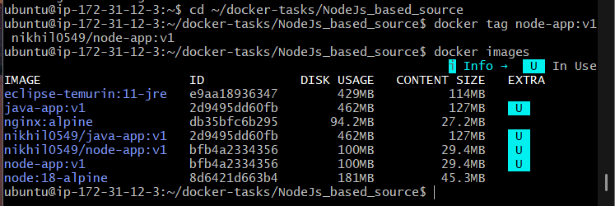

Step 8 — Push to Docker Hub
You already logged in earlier, so run:
docker push nikhil0549/node-app:v1
Wait until you see:
v1: digest: sha256:...
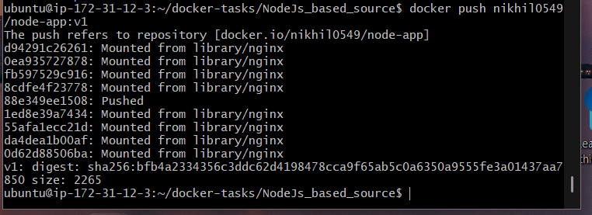

Step 9 — Verify
Run:
docker pull nikhil0549/node-app:v1

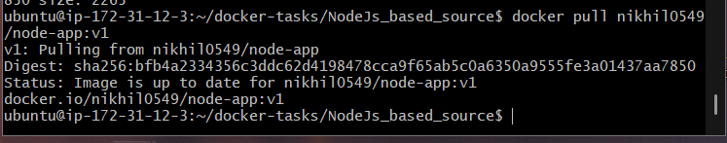
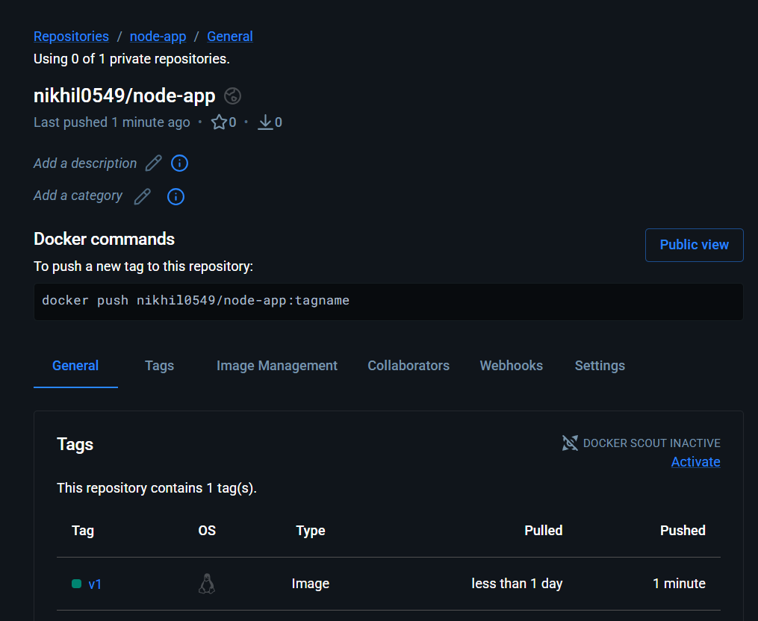

Docker Compose: WordPress + MySQL
For this task, we need to create a docker-compose.yml that starts two containers:
Docker Compose
│
┌───────────┴───────────┐
│ │
WordPress MySQL
Port 8084 Port 3306
│ │
└────── Docker Network ─┘
We'll keep MySQL internal and expose only WordPress on port 8084.

Step 1 — Go to docker-tasks
cd ~/docker-tasks
Check:
pwd
It should show:
/home/ubuntu/docker-tasks

Step 2 — Check Docker Compose
Run:
docker compose version
You should get something like:
Docker Compose version v2.x.x
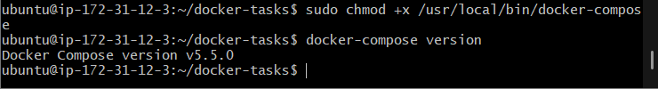

Step 3 — Create the Compose file
Run:
vi docker-compose.yml
Add:
services:

mysql:
image: mysql:8.0
container_name: wordpress-db
restart: unless-stopped
environment:
MYSQL_DATABASE: wordpress
MYSQL_USER: wordpress
MYSQL_PASSWORD: wordpress123
MYSQL_ROOT_PASSWORD: root123
volumes:
- mysql_data:/var/lib/mysql

wordpress:
image: wordpress:latest
container_name: wordpress
restart: unless-stopped
depends_on:
- mysql
ports:
- "8084:80"
environment:
WORDPRESS_DB_HOST: mysql:3306
WORDPRESS_DB_USER: wordpress
WORDPRESS_DB_PASSWORD: wordpress123
WORDPRESS_DB_NAME: wordpress

volumes:
mysql_data:
Save and exit.

Step 4 — Verify the file
Run:
cat docker-compose.yml
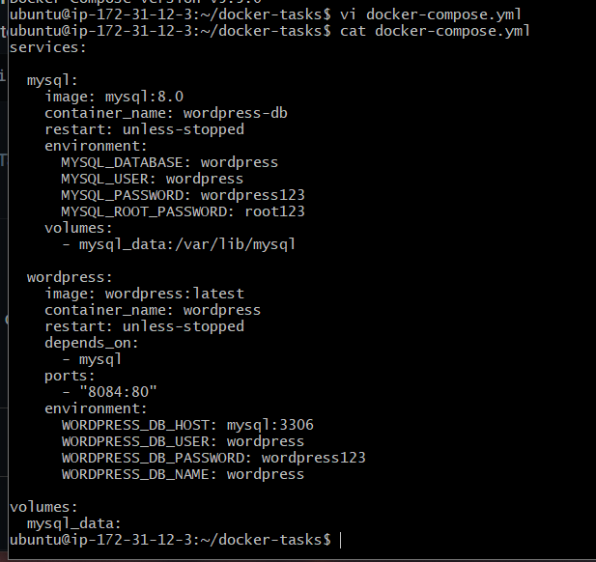
Check that:
WORDPRESS_DB_HOST: mysql:3306
is present.
Important: mysql here is the Compose service name. WordPress uses it as the hostname to communicate with the MySQL container.

Step 5 — Validate Compose configuration
Run:
docker compose config
If there are no errors, the Compose file is valid.
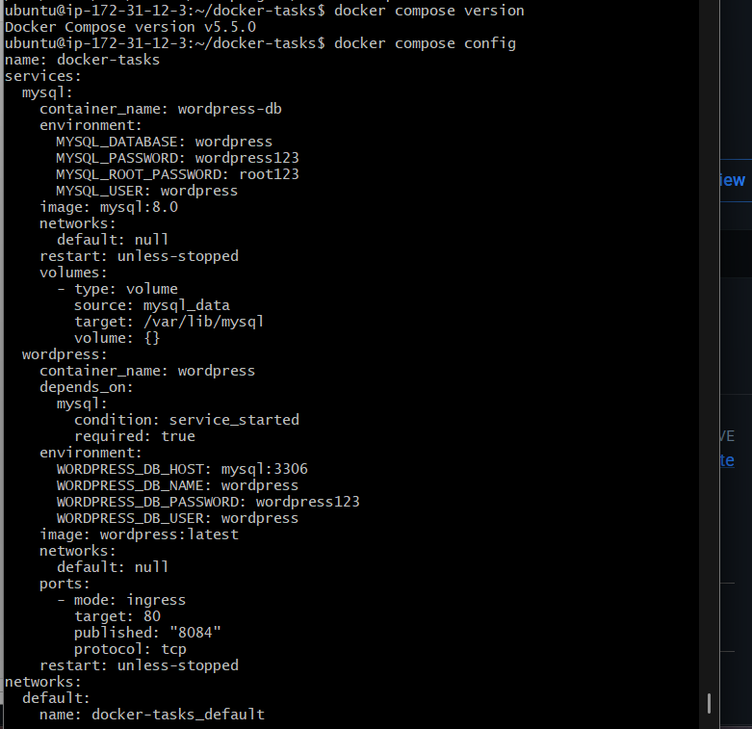

Step 6 — Start WordPress and MySQL
Run:
docker compose up -d
This will download:
mysql:8.0
wordpress:latest
and create both containers.
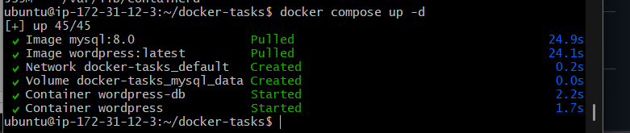
Then:
docker compose ps
You should eventually see something similar to:
NAME STATUS PORTS
wordpress Up 0.0.0.0:8084->80/tcp
wordpress-db Up 3306/tcp
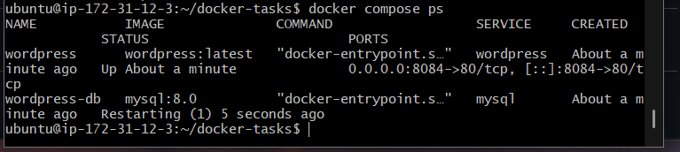

Step 7 — Check the logs
Run:
docker compose logs --tail=50
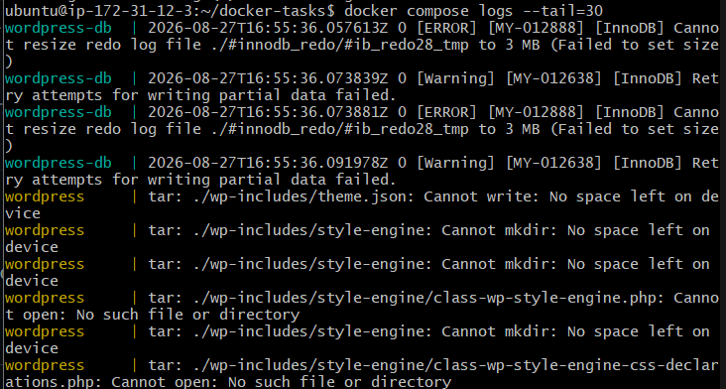
If WordPress is still initializing, wait about 30–60 seconds and check:
docker compose ps
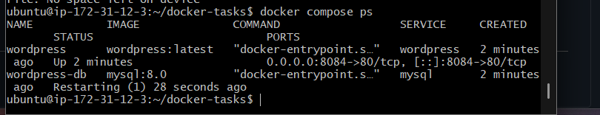

Step 8 — Test WordPress
Open:
http://<EC2-PUBLIC-IP>:8084
You should get the WordPress installation page.
For example, if your EC2 public IP were 18.215.63.23:
http://18.215.63.23:8084
